Supplementary Material for ”Group-Based Community Interventions for Social Reintegration of Marginalized Adults with Mental Illness: A Systematic Review and Meta-Analysis”
Table of Contents
Potential biases in the review process 2
Further descriptive statistics 2
Detailed forest plots 8
Sensitivity analysis visualized 10
Publication bias table for the overall average effects 12
Moderator analyses across social reintegration and mental health 12
Detailed overview of included outcomes 19
Search methods for identification of studies 23
Electronic searches 24
Searching other resources 24
Treatment measurement and effect size calculation 26
Further details about the data synthesis 32
Unit of analysis issues 32
Criteria for the determination of independent findings (dependent effect sizes) 32
Dealing with missing data 33
Assessment of heterogeneity 34
Overall average effect – PECHE-RVE 34
Subgroup analysis and investigation of heterogeneity 36
Sensitivity analysis 39
Assessment of reporting biases 39
Reference 45

Potential biases in the review process
We performed a comprehensive electronic database search, combined with grey literature searching, backwards citation tracking, and hand searching of key journals. All citations were screened by two independent screeners from the review team, and one review author (NTD) assessed all included studies against the inclusion criteria. We believe that nearly all the publicly available studies on the effects of group-based interventions for marginalized adults suffering from both mental illness and social problems within the OECD countries were identified during the review process. However, 35 references were not obtained in full text. This can potentially be a source of bias in the review. Similarly, it can have induced bias that we were not able to include all studies, as we could not calculate the effect size for 12 studies. However, as illustrated in Figure S1, we did not find any indication that the 12 excluded studies reached a different conclusion than our review.

Fig. S1 | Bar plot illustrating directions of overall conclusions from the 12 studies without effect sizes
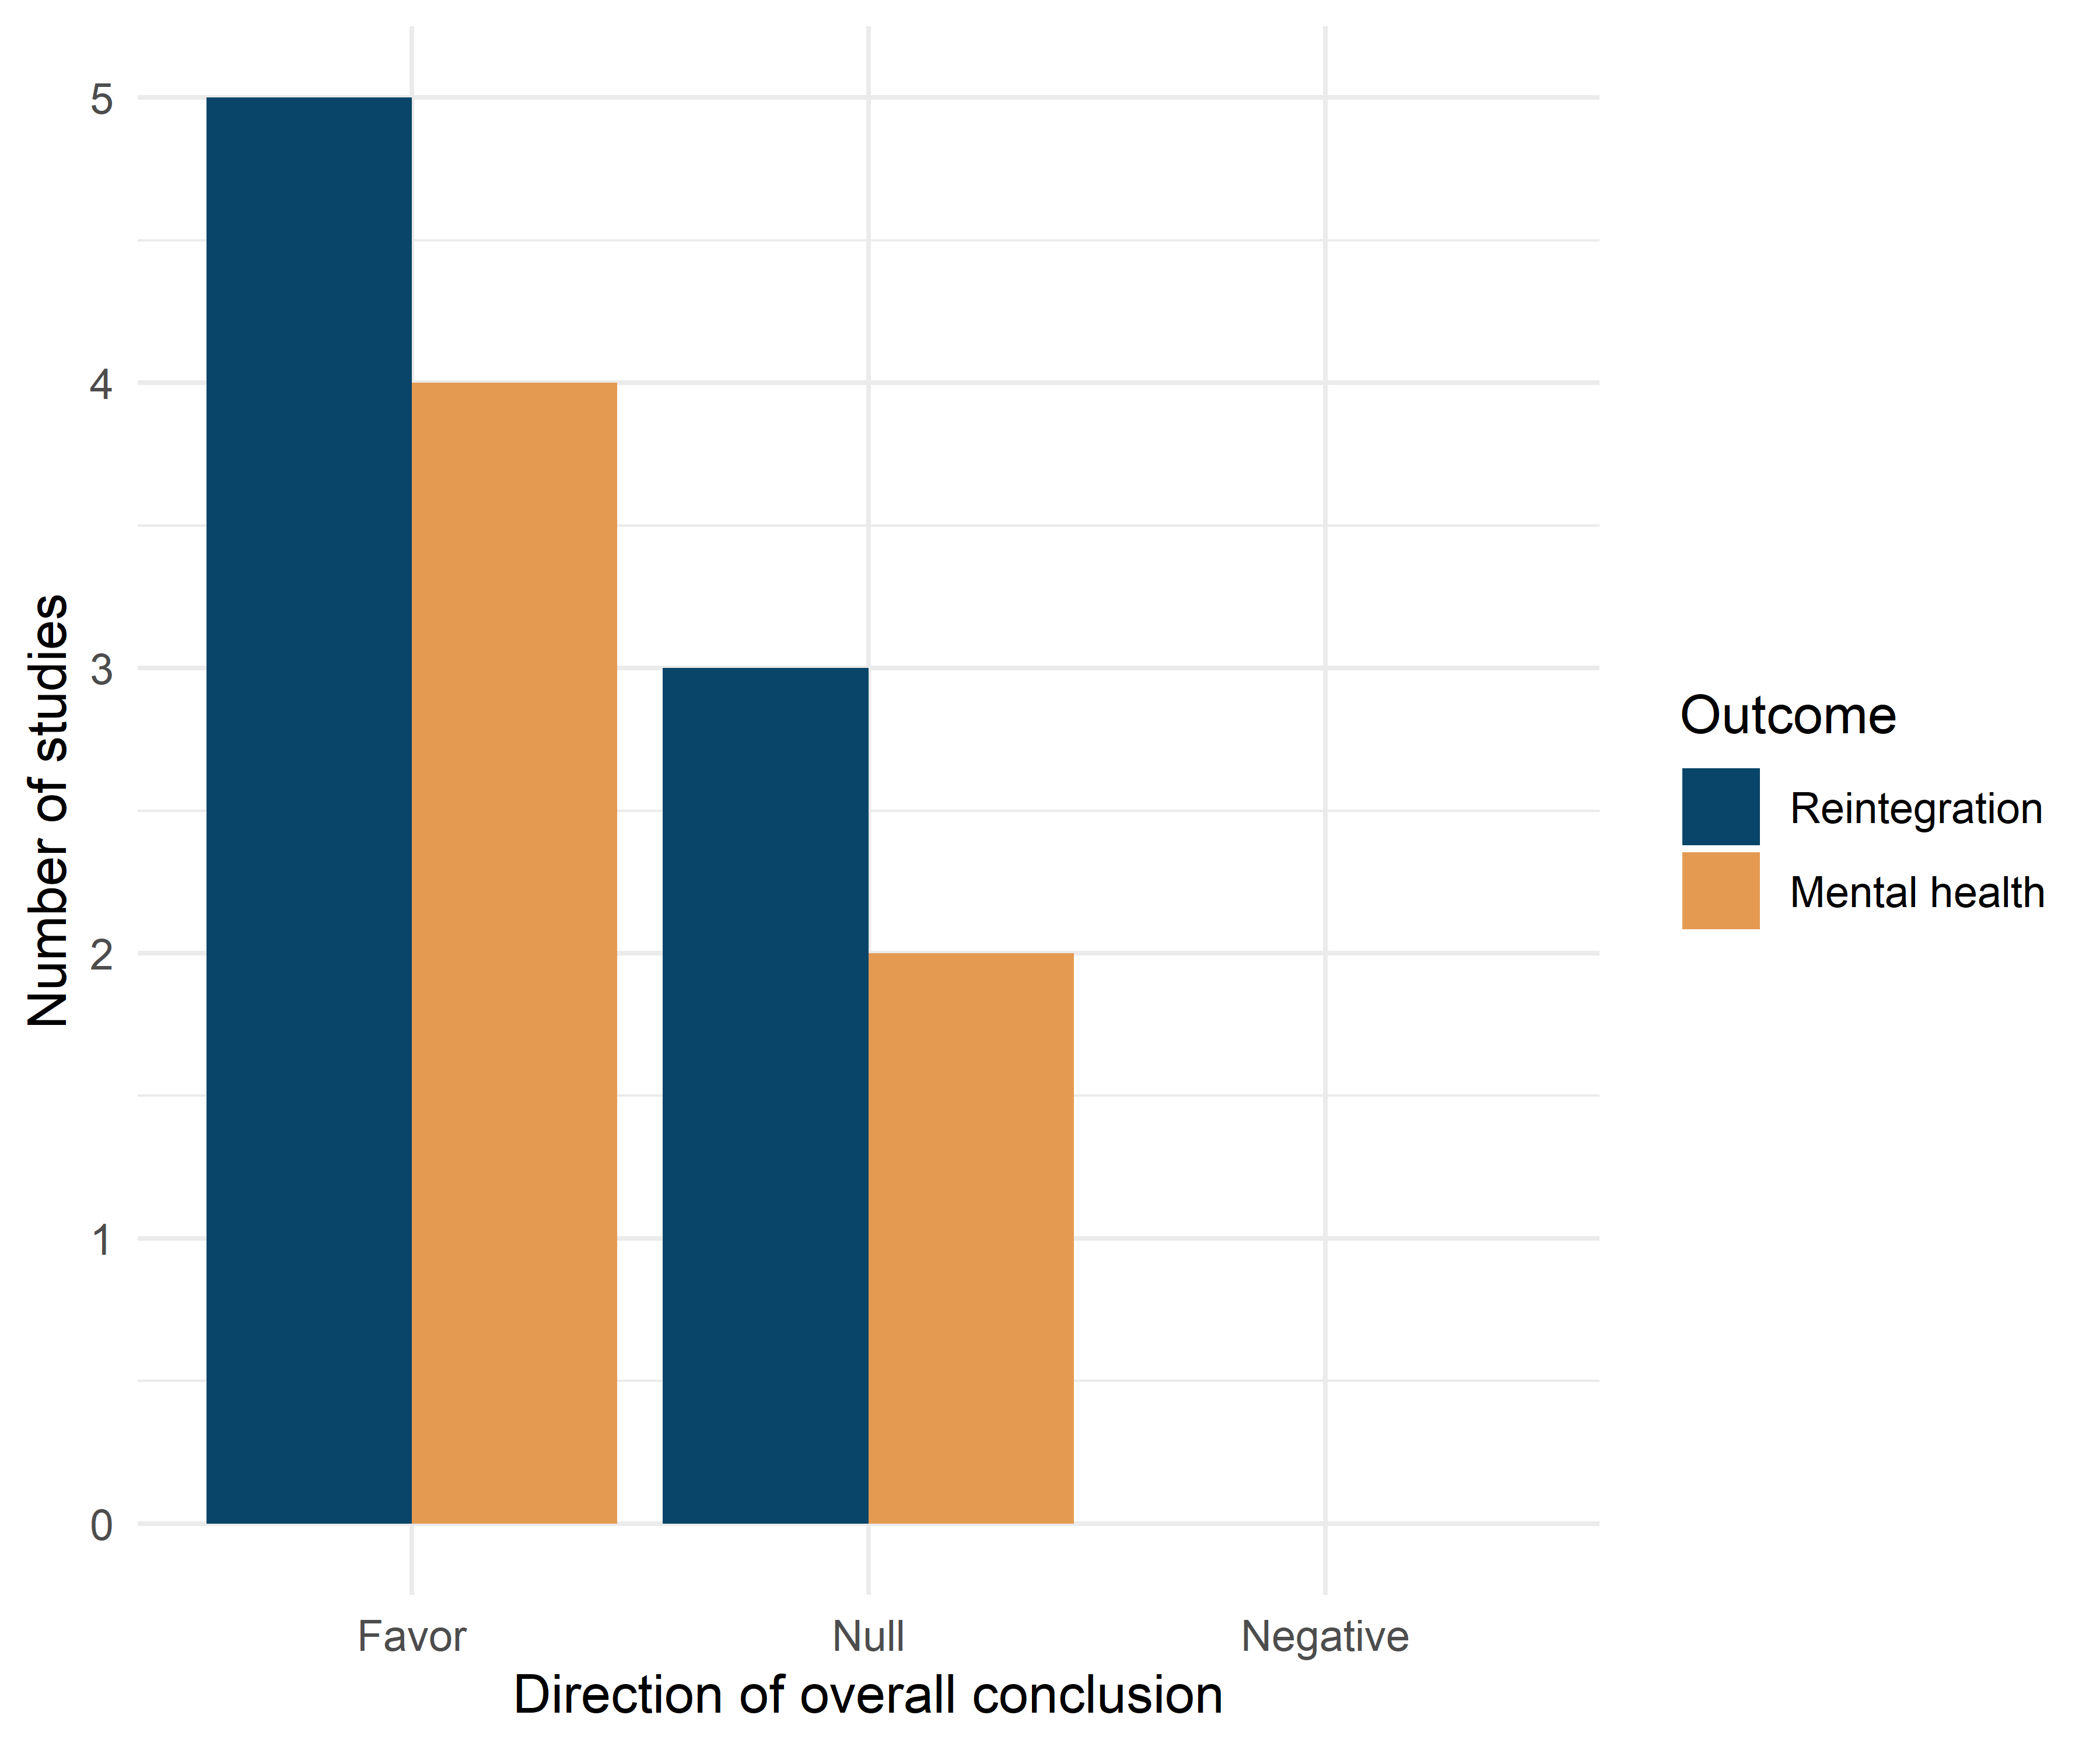

Further descriptive statistics
Table S1 describes the included participants by primary type of mental disorder and primary indicator of marginalization. Table S2 presents descriptive averages for studies that reported social reintegration outcomes. Tables S2 and S3 present descriptive statistics for studies reporting mental health outcomes.
Table S1 | Characteristics of participants
Characteristics of the participants | Studies | In meta-analysis
Mental health disorder
Schizophrenia or other primary psychotic disorders | 36 | 25
Depressive disorders | 25 | 23
Bipolar disorders | 20 | 15
Anxiety disorders | 15 | 14
Personality disordersᵃ | 10 | 9
Post-traumatic stress disorder | 9 | 9
Other mental health disordersᵇ | 9 | 9
Borderline personality disorder | 8 | 4
Obsessive-compulsive disorder | 3 | 3
Not specified | 5 | 3
Social marginalization
Substance abuseᶜ | 13 | 11
Other social problemsᵉ | 6 | 6
Chronic medical conditionsᵈ | 6 | 4
Unemployment | 5 | 2
Trauma experience | 3 | 3
Homelessness | 2 | 2
Loneliness | 2 | 2
Psychiatric comorbidity | 1 | 1
Criminal justice involvement | 1 | 0
Not clearly specified | 28 | 21
Note. Participants with different mental health disorders and indicators of social marginalization could appear within the same study. Therefore, the categories are not mutually exclusive, and the columns sum to more than 62 and 49 studies, respectively.
ª If specified, primarily DSM cluster C personality disorders.
^{b} Including dissociative identity disorder, autism spectrum disorder, eating disorders, other psychotic disorders, suicidal ideation, and elevated levels of psychological stress
^{c} Including both alcohol and drugs
^{d} Including both psychiatric and somatic chronic conditions
^{e} Including living in residential group homes, being older than 60 years old, and self-reported social problems such as having experienced disruptive periods, elevated internalized stigma, and experiencing social or cognitive disability
Table S2 Descriptive means of included studies reporting social reintegration outcomes

Characteristics | Studies (j) | Effects (k) | $$Median_{j}$$ | $$Mean_{j}$$ | $$SD_{j}$$ | Range
Sample characteristics
Raw treatment sample size | 46 | 205 | 29.00 | 58.00 | 60.80 | 7-315
Raw control sample size | 46 | 205 | 30.00 | 54.00 | 60.20 | 9-316
Total sample size | 46 | 205 | 60.00 | 118.00 | 127.20 | 16-631
Effective treatment sample size | 46 | 205 | 19.00 | 34.00 | 35.00 | 4-175
Effective control sample size | 46 | 205 | 19.00 | 32.00 | 34.60 | 5-176
Total effective sample size | 46 | 205 | 38.00 | 70.00 | 73.30 | 10-351
Average age in studies | 46 | 205 | 40.80 | 40.70 | 8.90 | 25-67
% Males | 45 | 202 | 46.30 | 46.60 | 23.40 | 0-81
Intervention characteristics
Average group size | 27 | 133 | 8.00 | 7.90 | 3.20 | 4-22
Total number of sessions | 45 | 201 | 12.00 | 21.00 | 21.90 | 3-104
Sessions per week | 45 | 201 | 1.00 | 1.30 | 1.50 | 0-10.5
Duration (in weeks) | 46 | 205 | 12.00 | 18.30 | 16.90 | 4-78
Measurement timing
After end of intervention (in weeks) | 46 | 205 | 0.50 | 9.80 | 15.90 | 0-52
From baseline (in weeks) | 46 | 205 | 22.00 | 28.10 | 26.10 | 6-130
Methodological features
Pre-posttest correlation (empirically computed)ª | 9 | 24 | 0.76 | 0.62 | 0.22 | 0.187-0.915
Note.
ª Computed at the effect size level

Table S3 | Descriptive percentages for the included studies for mental health outcomes
Characteristics | Studies (j) | Effects (k) | % Studies | % Effects
Context
Australia | 9 | 22 | 21.4 | 15.3
Austria | 1 | 2 | 2.4 | 1.4
Canada | 2 | 3 | 4.8 | 2.1
Korea | 1 | 5 | 2.4 | 3.5
Finland | 2 | 3 | 4.8 | 2.1
Germany | 4 | 26 | 9.5 | 18.1
Ireland | 1 | 6 | 2.4 | 4.2
Italy | 2 | 4 | 4.8 | 2.8
Japan | 1 | 2 | 2.4 | 1.4
Netherlands | 2 | 4 | 4.8 | 2.8
Norway | 2 | 5 | 4.8 | 3.5
Spain | 2 | 21 | 4.8 | 14.6
Turkey | 1 | 4 | 2.4 | 2.8
UK | 3 | 7 | 7.1 | 4.9
US | 9 | 30 | 21.4 | 20.8
Outcome measure
Anxiety | 9 | 14 | 21.4 | 9.7
Depression | 20 | 37 | 47.6 | 25.7
General mental health | 29 | 72 | 69.0 | 50.0
Symptoms of psychosis | 7 | 21 | 16.7 | 14.6
Diagnosis in sample
Schizophrenia | 7 | 14 | 16.7 | 9.7
Other | 35 | 130 | 83.3 | 90.3
Intervention type
CBT | 12 | 49 | 28.6 | 34.0
Other | 31 | 95 | 73.8 | 66.0
Preregistration status
Not preregistered | 22 | 62 | 52.4 | 43.1
Preregistered | 20 | 82 | 47.6 | 56.9
Outlet
Journal article | 42 | 144 | 100.0 | 100.0
Research design
QES | 8 | 17 | 19.0 | 11.8
RCT | 34 | 127 | 81.0 | 88.2
Test type
Clinician-rated measure | 14 | 41 | 33.3 | 28.5
Self-reported | 33 | 103 | 78.6 | 71.5
Analysis strategy
ITT | 18 | 69 | 42.9 | 47.9
TOT | 24 | 75 | 57.1 | 52.1
Control group
Individual treatment | 2 | 3 | 4.8 | 2.1
TAU | 28 | 108 | 66.7 | 75.0
TAU with Waiting-list | 9 | 26 | 21.4 | 18.1
Waiting-list only | 3 | 7 | 7.1 | 4.9
Overall risk of bias
Low | 10 | 36 | 23.8 | 25.0
Some concerns/Moderate | 20 | 79 | 47.6 | 54.9
Serious/High | 13 | 29 | 31.0 | 20.1
Timing of measurement
Short-term measure (< 52 weeks) | 42 | 144 | 100.0 | 100.0
Effect size metric
Pre-posttest adj. ES | 42 | 144 | 100.0 | 100.0
Handles multilevel structure
No | 40 | 140 | 95.2 | 97.2
Yes | 2 | 4 | 4.8 | 2.8
Note: ES = Effect size, ITT = Intention-To-Treat; TOT; Treatment-On-the-Treated; QES = Quasi-Experimental Design (non-randomized); RCT = Randomized Controlled Trial; TAU = Treatment as usual; CBT = cognitive behavioral therapy.

Table S4 | Descriptive means of included studies reporting mental health outcomes

Characteristics | Studies (j) | Effects (k) | $$Median_{j}$$ | $$Mean_{j}$$ | $$SD_{j}$$ | Range
Sample characteristics
Raw treatment sample size | 42 | 144 | 28.00 | 54.00 | 59.40 | 7-315
Raw control sample size | 42 | 144 | 29.00 | 51.00 | 58.30 | 9-316
Total sample size | 42 | 144 | 60.00 | 111.00 | 125.00 | 16-631
Effective treatment sample size | 42 | 144 | 20.00 | 33.00 | 33.90 | 4-175
Effective control sample size | 42 | 144 | 19.00 | 30.00 | 33.20 | 5-176
Total effective sample size | 42 | 144 | 38.00 | 67.00 | 71.50 | 10-351
Average age in studies | 42 | 144 | 39.70 | 39.60 | 9.30 | 22-67
% Males | 41 | 143 | 46.30 | 45.30 | 23.50 | 0-81
Intervention characteristics
Average group size | 26 | 92 | 7.00 | 7.10 | 1.60 | 4-10
Total number of sessions | 41 | 143 | 13.00 | 21.60 | 22.50 | 3-104
Sessions per week | 41 | 143 | 1.00 | 1.30 | 1.50 | 0-10.5
Duration (in weeks) | 42 | 144 | 12.00 | 19.30 | 17.50 | 4-78
Measurement timing
After end of intervention (in weeks) | 42 | 144 | 1.00 | 10.70 | 16.60 | 0-52
From baseline (in weeks) | 42 | 144 | 22.00 | 30.10 | 27.40 | 6-130
Methodological features
Pre-posttest correlation (empirically computed)ª | 9 | 18 | 0.48 | 0.51 | 0.17 | 0.12-0.76
Note.
ª Computed at the effect size level

Detailed forest plots
Figure S2 and S3 present more outcome-specific forest plot, including specific weight attributed to each effect size within the given study and the overall average effect size.
Fig. S2 | Effect size forest plot with dependent effect sizes for social reintegration outcomes
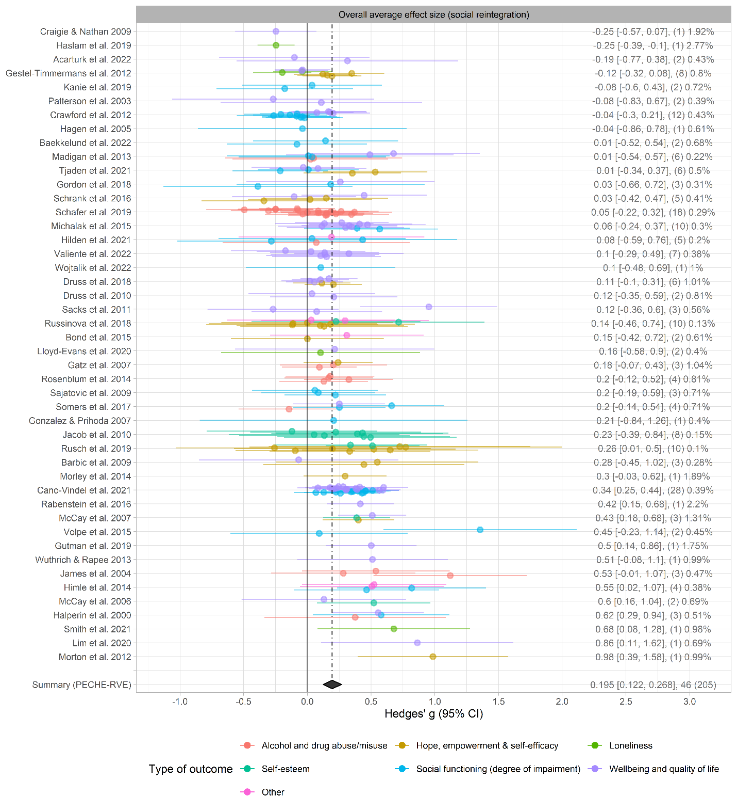
Note: The number of effect size estimates is in parentheses. The percentages indicate the weight given to each effect size within the given study. Studies are ordered by the study mean effect size obtained from fitting the within-study effect sizes to a univariate meta-analysis model, as suggested by Fernández-Castilla, Declercq, et al.¹ The dashed line indicates the overall average effect size (g = .195), and the diamond indicates the 95% confidence interval from the fitted PECHE-RVE model.
Fig. S3 | Effect size forest plot with dependent effect sizes for mental health outcomes
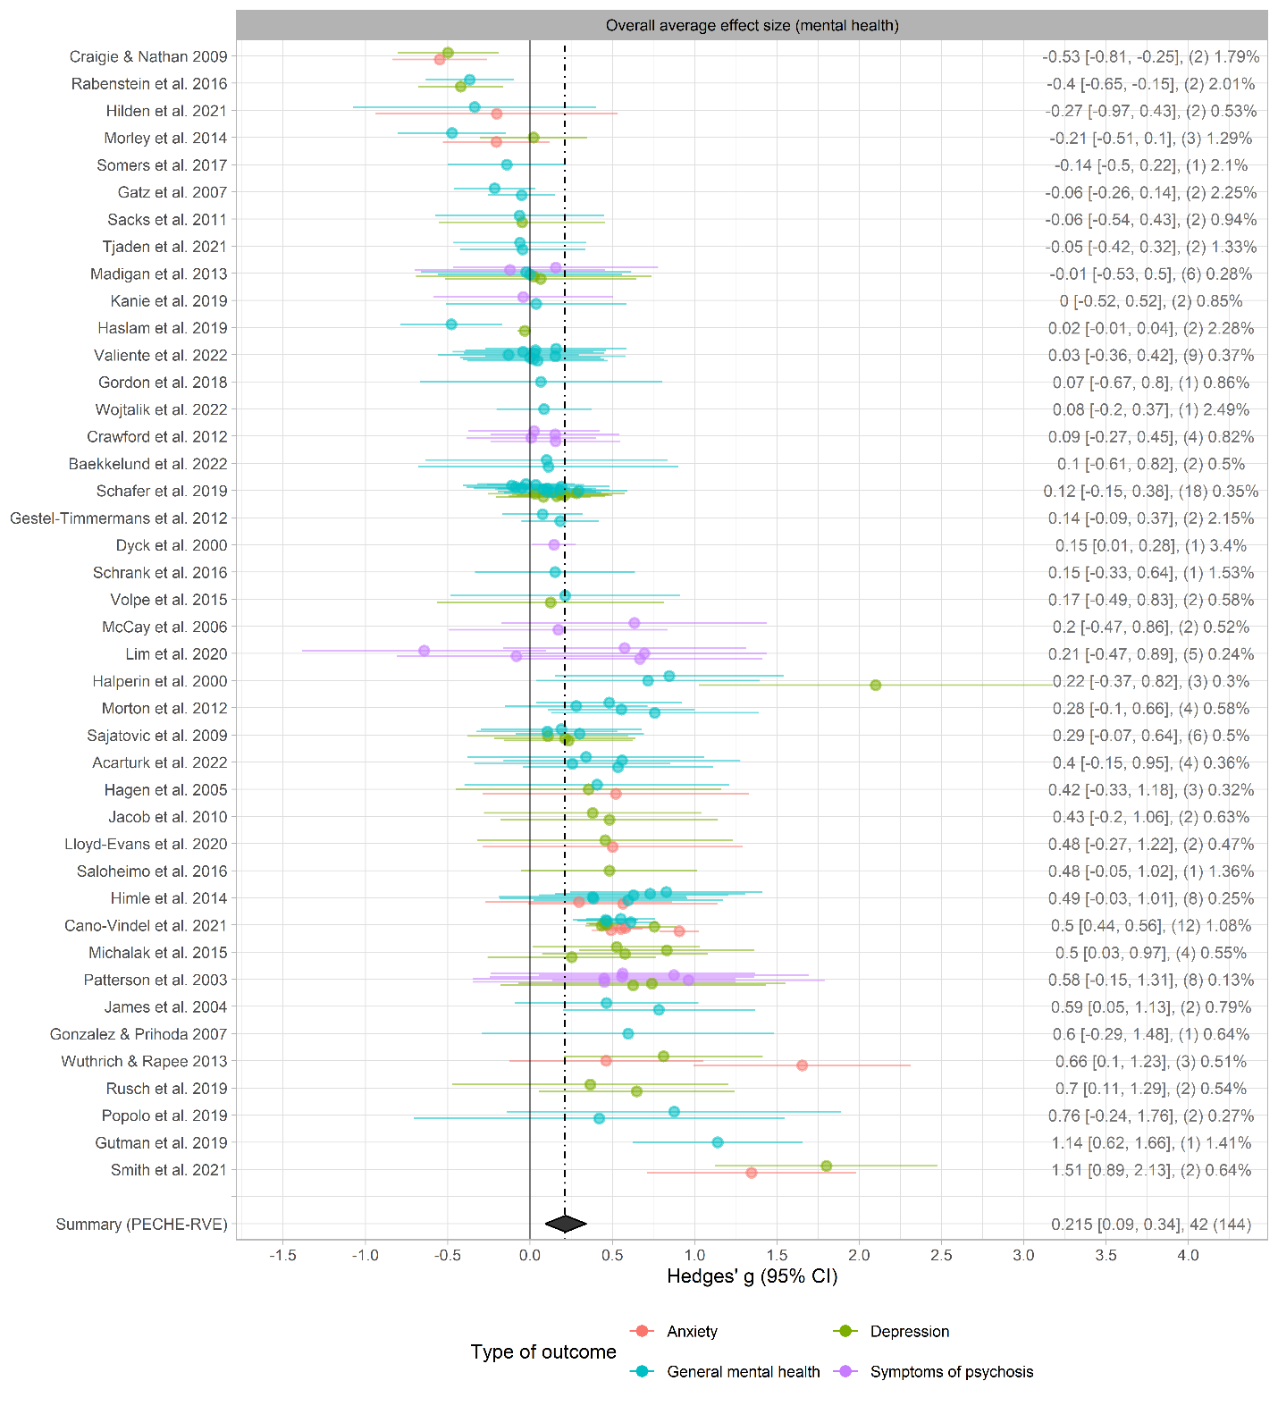
Note: The number of effect size estimates is in parentheses. The percentages indicate the weight given to each effect size within the given study. Studies are ordered by the study mean effect size obtained from fitting the within-study effect sizes to a univariate meta-analysis model, as suggested by Fernández-Castilla, Declercq, et al.¹ The dashed line indicates the overall average effect size (g = .215), and the diamond indicates the 95% confidence interval from the fitted PECHE-RVE.

Sensitivity analysis visualized
Figures S4-S5 present sensitivity analyses while changing effect size calculation assumptions and inclusion criteria for social reintegration and mental health outcomes, respectively.
Fig. S4 | Sensitivity analyses changing effect size calculation assumptions and inclusion criteria for social reintegration outcomes
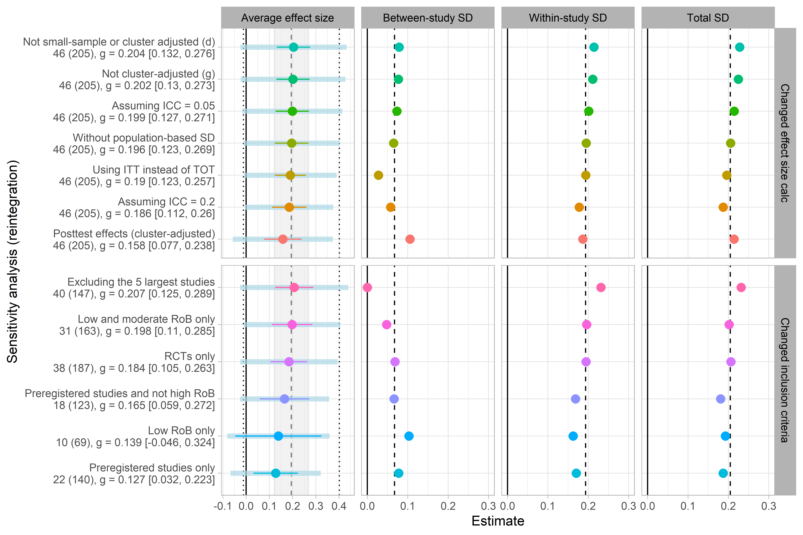
Note: Dashed lines indicate the estimated values from the main analysis. The gray shading in the first column represents the width of the confidence interval from the main analysis, while the point lines indicate the re-estimated confidence intervals. Dotted lines indicate the 67% prediction interval estimated from the main analysis, and the blue bands in the first column represent the re-estimated 67% prediction intervals.

Fig. S5 | Sensitivity analyses changing effect size calculation and inclusion criteria for mental health outcomes
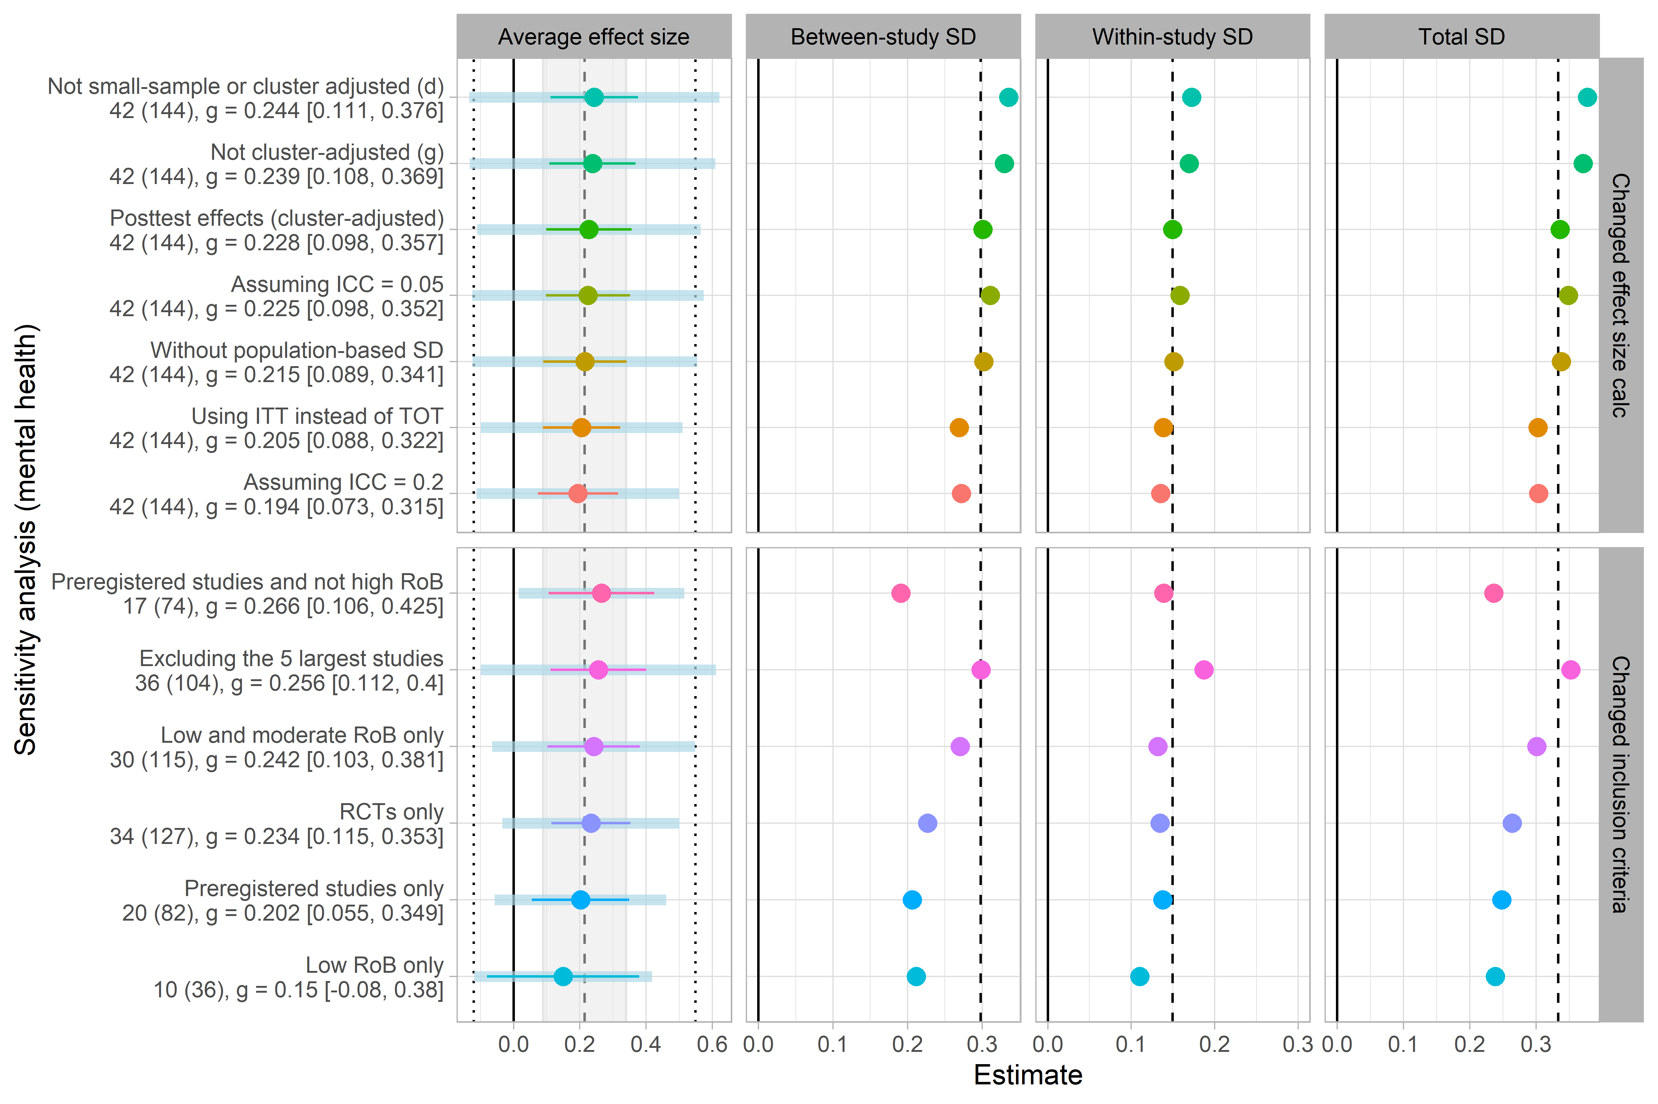
Note: Dashed lines indicate the estimated values from the main analysis. The gray shading in the first column represents the width of the confidence interval from the main analysis, while the point lines indicate the reestimated confidence intervals. Dotted lines indicate the 67% prediction interval estimated from the main analysis, and the blue bands in the first column represent the re-estimated 67% prediction intervals.

Publication bias table for the overall average effects
Table S5 | Overall average effects across different publication bias-adjusted models
Analysis | Studies | Effects | Est [95% CI] | p-val | τ | ω | SD √(τ²+ω²) | λ₁ | λ₂
Social reintegration
Bootstrap HYEMA | 46 | 205 | 0.187 [0.089, 0.195] | - | 0.176 | - | 0.176 | - | -
Puniform* | 46 | 205 | 0.245 [0.185, 0.312] | 0.000 | 0.203 | - | 0.203 | - | -
Worst-case meta-analysis | 40 | 157 | 0.078 [0.025, 0.130] | 0.006 | 0.000 | 0.149 | 0.149 | - | -
CHE-ISCW | 46 | 205 | 0.201 [-0.174, 0.575] | 0.152 | 0.076 | 0.197 | 0.211 | - | -
PET/PEESE (ISCW)ª | 46 | 205 | 0.246 [-1.403, 1.895] | 0.513 | 0.073 | 0.194 | 0.207 | - | -
Bootstrap 3PSM | 46 | 205 | 0.233 [0.139, 0.329] | - | 0.186 | - | 0.186 | 1.478 | -
Bootstrap 4PSM | 46 | 205 | 0.189 [0.029, 0.315] | - | 0.200 | - | 0.200 | 1.304 | 0.854
Mental health
Bootstrap HYEMA | 42 | 144 | 0.290 [0.131, 0.436] | - | 0.325 | - | 0.325 | - | -
Puniform* | 42 | 144 | 0.598 [0.454, 0.763] | 0.000 | 0.421 | - | 0.421 | - | -
Worst-case meta-analysis | 37 | 108 | 0.069 [-0.031, 0.170] | 0.168 | 0.169 | 0.100 | 0.196 | - | -
CHE-ISCW | 42 | 144 | 0.163 [-2.184, 2.510] | 0.647 | 0.338 | 0.169 | 0.378 | - | -
PET/PEESE (ISCW)ª | 42 | 144 | -0.063 [-1.489, 1.362] | 0.880 | 0.315 | 0.172 | 0.359 | - | -
Bootstrap 3PSM | 42 | 144 | 0.426 [0.229, 0.737] | - | 0.359 | - | 0.359 | 2.927 | -
Bootstrap 4PSM | 42 | 144 | 0.324 [0.021, 0.629] | - | 0.393 | - | 0.393 | 2.565 | 1.296
Note. Confidence intervals for bootstrap models are percentile confidence intervals. HYEMA = Hybrid Extended Meta-Analysis. 3PSM = three-parameter selection model, 4PSM = four-parameter selection model, CHE = correlated-hierarchical effects, ISCW = inverse sampling covariance weights, PET = precision effect test, PEESE = precision-effect estimator with standard error $τ$ = between-study variance, $ω$ = within-study variance, $λ$ = selection ratio parameter.
ª Included control for preregistration.

Moderator analyses across social reintegration and mental health
In this section, we present all moderator analyses conducted for the review. The results can be found in Tables S6-S11, below.
Table S6 | Substantive categorical moderators meta-analysis of social reintegration outcomes
Subgroup-analyses |  |  | Unadjusted effects |  |  |  | Covariate-adjusted effectsª
Moderator | Studies | Effects | Est. [95% CI] | p-val | Satt. df | SD $\sqrt{τ^{2}+ω^{2}}$ | Est. [95% CI]  F-statistics | p-val | Satt. df | SD$\sqrt{τ^{2}+ω^{2}}$
Outcome type | 46 | 205
Alcohol/drug use | 8 | 32 | 0.12 [-0.08, 0.31] | 0.161 | 3.6 | 0.21 | 0.22 [0.06, 0.38] | 0.016 | 6.7 | 0.21
Hope | 12 | 32 | 0.23 [0.11, 0.34] | 0.003 | 7.5 | 0.16 | 0.24 [0.09, 0.38] | 0.004 | 10.2 | 0.16
Loneliness | 4 | 5 | 0.02 [-0.63, 0.66] | 0.938 | 2.6 | 0.31 | -0.03 [-0.25, 0.2] | 0.732 | 3.2 | 0.08
Self-esteem | 5 | 14 | 0.42 [0.31, 0.54] | 0.001 | 3.4 | 0.15 | 0.41 [0.24, 0.59] | 0.003 | 4.2 | 0.15
Social functioning | 17 | 48 | 0.18 [0.02, 0.34] | 0.027 | 10.8 | 0.21 | 0.18 [0.02, 0.34] | 0.031 | 11.4 | 0.19
Wellbeing & QoL | 25 | 68 | 0.22 [0.12, 0.32] | 0.000 | 13.0 | 0.18 | 0.2 [0.1, 0.29] | 0.000 | 14.6 | 0.16
Other | 4 | 6 | 0.32 [0.02, 0.62] | 0.044 | 2.8 | 0.00 | 0.34 [-0.11, 0.79] | 0.096 | 3.2 | 0.00
Wald test (CWB) |  |  |  | 0.267 |  |  |  | 0.200
Schizophrenia in sample | 46 | 205
Yes | 9 | 33 | 0.19 [-0.04, 0.42] | 0.086 | 6.3 | 0.22 | 0.3 [0.03, 0.56] | 0.032 | 6.5 | 0.16
No | 37 | 172 | 0.2 [0.12, 0.28] | 0.000 | 17.4 | 0.20 | 0.31 [0.09, 0.52] | 0.019 | 3.4 | 0.19
Wald test (CWB) |  |  |  | 0.954 |  |  |  | 0.926
Type of intervention | 46 | 205
CBT | 12 | 55 | 0.28 [0.11, 0.45] | 0.007 | 6.0 | 0.18 | 0.36 [0.15, 0.57] | 0.009 | 3.8 | 0.15
Other | 35 | 150 | 0.16 [0.08, 0.23] | 0.000 | 19.7 | 0.21 | 0.25 [0, 0.5] | 0.048 | 3.4 | 0.20
Wald test (CWB/HTZ)^{b} |  |  |  | 0.208 |  |  | F(1, 13.1) = 2.2 | 0.162
Note. Bold degrees of freedom (df) estimates indicate that low df values, which in turn indicate that the variance estimation for the corresponding coefficient is noisy. Following the recommendation of Wu et al. (2025), we do not make statistical significance inference unless the p-value is below 0.01 when $df<4$. Bold p-values (under the ‘p-val’-column) indicate that the coefficients are statistically different from zero at the set .05-level when $df>4$, whereas italic p-values in the coefficients are statistically different from zero at the set .05-level, when $df<4$ but failed to be rejected at the adjusted 0.01-level. Est. = Estimate; CI = Confidence Interval; p-val = p-value; Satt. df = Satterthwaite's degrees of freedom; SD = total standard deviation; CWB = Cluster Wild Bootstrap; ITT = Intention-To-Treat; TOT; Treatment-On-the-Treated; QES = Quasi-Experimental Design (non-randomized); RCT = Randomized Controlled Trial; TAU = Treatment as usual. ª Effects are adjusted for all factors listed in Tables 7, 8, and 9. The exception is the male and number of sessions indicators, as these factors were highly correlated with the sample composition and duration, respectively. Find this information in the PRIMED supplementary material Table 36. ^{b} For the covariate-adjusted model with the type of intervention as the main predictor, we had a convergence issue when estimating CWB p-values. Therefore, we reported HTZ Wald test p-values for this model.

Table S7 | Methodologically relevant categorical moderators meta-analysis of reintegrational outcomes
Subgroup-analyses |  |  | Unadjusted effects |  |  |  | Covariate-adjusted effectsª
Moderator | Studies | Effects | Est. [95% CI] | p-val | Satt. df | SD$\sqrt{τ^{2}+ω^{2}}$ | Est. [95% CI] | p-val | Satt. df | SD$\sqrt{τ^{2}+ω^{2}}$
Preregistered | 46 | 205
No | 24 | 65 | 0.31 [0.21, 0.42] | 0.000 | 18.0 | 0.26 | 0.42 [0.18, 0.65] | 0.007 | 4.6 | 0.25
Yes | 22 | 140 | 0.13 [0.03, 0.22] | 0.013 | 13.2 | 0.19 | 0.2 [-0.02, 0.42] | 0.067 | 3.4 | 0.16
Wald test (CWB) |  |  |  | 0.012 |  |  |  | 0.019
Test type | 46 | 205
Clinician-rated measure | 12 | 36 | 0.13 [-0.08, 0.35] | 0.169 | 4.9 | 0.22 | 0.25 [0.01, 0.5] | 0.043 | 6.4 | 0.21
Self reported/raw events | 39 | 169 | 0.21 [0.13, 0.29] | 0.000 | 22.6 | 0.20 | 0.31 [0.1, 0.52] | 0.018 | 3.3 | 0.17
Wald test (CWB) |  |  |  | 0.444 |  |  |  | 0.428
Analysis strategy | 46 | 205
ITT | 22 | 108 | 0.12 [0.04, 0.21] | 0.007 | 12.9 | 0.20 | 0.28 [0.08, 0.48] | 0.017 | 3.8 | 0.19
TOT | 24 | 97 | 0.27 [0.16, 0.38] | 0.000 | 10.7 | 0.19 | 0.34 [0.11, 0.58] | 0.015 | 3.9 | 0.17
Wald test (CWB) |  |  |  | 0.056 |  |  |  | 0.319
Research design | 46 | 205
QES | 8 | 18 | 0.28 [0.01, 0.56] | 0.046 | 5.8 | 0.23 | 0.29 [-0.03, 0.61] | 0.074 | 10.4 | 0.11
RCT | 38 | 187 | 0.18 [0.11, 0.26] | 0.000 | 20.4 | 0.21 | 0.31 [0.1, 0.52] | 0.019 | 3.1 | 0.18
Wald test (CWB) |  |  |  | 0.440 |  |  |  | 0.882
Control group | 46 | 205
Individual treatment | 3 | 4 | -0.06 [-0.82, 0.7] | 0.737 | 1.8 | 0.16 | -0.05 [-0.88, 0.78] | 0.851 | 2.8 | 0.34
TAU and Waitlist | 39 | 188 | 0.19 [0.12, 0.27] | 0.000 | 21.2 | 0.20 | 0.33 [0.13, 0.53] | 0.013 | 3.3 | 0.18
Waitlist only | 4 | 13 | 0.42 [0.12, 0.72] | 0.024 | 2.5 | 0.17 | 0.34 [-0.41, 1.09] | 0.285 | 4.4 | 0.29
Wald test (CWB) |  |  |  | 0.107 |  |  |  | 0.570
Serious/high risk of bias | 46 | 205
No | 31 | 163 | 0.2 [0.11, 0.29] | 0.000 | 14.3 | 0.20 | 0.32 [0.12, 0.52] | 0.013 | 3.7 | 0.19
Yes | 16 | 42 | 0.2 [0.02, 0.38] | 0.030 | 12.4 | 0.26 | 0.25 [0.07, 0.43] | 0.018 | 4.6 | 0.12
Wald test (CWB) |  |  |  | 0.947 |  |  |  | 0.409
Note. Bold degrees of freedom (df) estimates indicate that low df values, which in turn indicate that the variance estimation for the corresponding coefficient is noisy. Following the recommendation of Wu et al. (2025), we do not make statistical significance inference unless the p-value is below 0.01, when $df<4$. Bold p-values (under the ‘p-val’-column) indicate that the coefficients are statistically different from zero at the set .05-level when $df>4$, whereas italic p-values in the coefficients are statistically different from zero at the set .05-level, when $df<4$ but failed to be rejected at the adjusted 0.01-level. Est. = Estimate; CI = Confidence Interval; p-val = p-value; Satt. df = Satterthwaite's degrees of freedom; SD = total standard deviation; CWB = Cluster Wild Bootstrap; ITT = Intention-To-Treat; TOT; Treatment-On-the-Treated; QES = Quasi-Experimental Design (non-randomized); RCT = Randomized Controlled Trial; TAU = Treatment as usual. ª Effects are adjusted for all factors listed in Tables 7, 8, and 9. The exception is the male and number of sessions indicators, as these factors were highly correlated with the sample composition and duration, respectively. Find this information in the PRIMED supplementary material Table 36.
Table S8 | Substantive continuous moderators meta-analysis of social reintegration outcomes
Moderator | Model 1 | Model 2 | Model 3 | Model 4 | Model 5 | Model 6ª
Age | 0.003 (0.005) |  |  |  |  | 0.003 (0.005)
% Male |  | 0.133 (0.152) |  |  |  | -0.006 (0.185)
Sessions |  |  | 0.021 (0.012) |  |  | -0.002 (0.015)
Duration |  |  |  | -0.003 (0.002) |  | 0 (0.002)
Follow-up timing |  |  |  |  | 0 (0.001) | 0 (0.001)
Intercept | 0.191 (0.038)*** | 0.204 (0.037)*** | 0.19 (0.037)*** | 0.213 (0.039)*** | 0.197 (0.033)*** | 0.293  (0.064)*
Study-level SD | 0.072 | 0.079 | 0.074 | 0.056 | 0.067 | 0
Effect-level SD | 0.193 | 0.193 | 0.193 | 0.194 | 0.194 | 0.182
Total SD | 0.206 | 0.208 | 0.207 | 0.202 | 0.205 | 0.182
Number of effects | 205 | 205 | 205 | 205 | 205 | 205
Number of studies | 46 | 46 | 46 | 46 | 46 | 46

Note: *p < .05, **p < .01, ***p < .001. Italic numbers indicate that the degrees of freedom are below four. SD = Standard Deviation.
Cluster robust standard errors in parentheses.
ª Effects are adjusted for all factors listed in Tables 7 and 8. The exception is the male and number of sessions indicators, as these factors were highly correlated with the sample composition and duration, respectively. Find this information in the PRIMED supplementary material Table 36.

Table S9 | Substantive categorical moderators meta-analysis of mental health outcomes
Subgroup-analyses |  |  | Unadjusted effects |  |  |  | Covariate-adjusted effectsª
Moderator | Studies | Effects | Est. [95% CI] | p-val | Satt. df | SD $\sqrt{τ^{2}+ω^{2}}$ | Est. [95% CI]  F-statistics | p-val | Satt. df | SD$\sqrt{τ^{2}+ω^{2}}$
Outcome type | 42 | 144
Anxiety | 9 | 14 | 0.4 [-0.07, 0.86] | 0.082 | 7.3 | 0.56 | 0.21 [-0.12, 0.54] | 0.163 | 5.7 | 0.40
Depression | 20 | 37 | 0.34 [0.09, 0.59] | 0.011 | 18.1 | 0.47 | 0.27 [0.05, 0.49] | 0.017 | 15.0 | 0.29
General mental health | 29 | 72 | 0.13 [-0.01, 0.28] | 0.074 | 25.4 | 0.30 | 0.25 [0.11, 0.38] | 0.001 | 17.5 | 0.17
Symptoms of psychosis | 7 | 21 | 0.16 [-0.01, 0.33] | 0.055 | 4.6 | 0.28 | 0.21 [0.03, 0.38] | 0.029 | 7.5 | 0.28
Wald test (CWB) |  |  |  | 0.418 |  |  |  | 0.897
Schizophrenia in sample | 42 | 144
Yes | 7 | 14 | 0.10 [0.04, 0.16] | 0.009 | 3.8 | 0.00 | 0.22 [0, 0.43] | 0.047 | 7.3 | 0.00
No | 35 | 130 | 0.23 [0.09, 0.38] | 0.003 | 31.6 | 0.37 | 0.19 [0.03, 0.36] | 0.026 | 8.2 | 0.27
Wald test (CWB/HTZ)^{b} |  |  |  | 0.100 |  |  | F(1, 9.15) = 0.1 | 0.763
Type of intervention | 42 | 144
CBT | 12 | 49 | 0.36 [-0.01, 0.72] | 0.054 | 10.8 | 0.53 | 0.27 [-0.09, 0.63] | 0.126 | 13.0 | 0.44
Other | 31 | 95 | 0.15 [0.04, 0.26] | 0.008 | 23.3 | 0.20 | 0.16 [0.03, 0.29] | 0.024 | 7.4 | 0.11
Wald test (CWB) |  |  |  | 0.275 |  |  |  | 0.576
Note. Bold degrees of freedom (df) estimates indicate that low df values, which in turn indicate that the variance estimation for the corresponding coefficient is noisy. Following the recommendation of Wu et al. (2025), we do not make statistical significance inference unless the p-value is below 0.01, when $df<4$. Bold p-values (under the ‘p-val’-column) indicate that the coefficients are statistically different from zero at the set .05-level when $df>4$, whereas italic p-values in the coefficients are statistically different from zero at the set .05-level, when $df<4$ but failed to be rejected at the adjusted 0.01-level. Est. = Estimate; CI = Confidence Interval; p-val = p-value; Satt. df = Satterthwaite's degrees of freedom; SD = total standard deviation; CWB = Cluster Wild Boostrap; ITT = Intention-To-Treat; TOT; Treatment-On-the-Treated; QES = Quasi-Experimental Design (non-randomized); RCT = Randomized Controlled Trial; TAU = Treatment as usual. ª Effects are adjusted for all factors listed in Tables 10, 11, and 12. The exception is the risk of bias, control group, and number of sessions indicators, as these factors were highly correlated with the research design, age, and duration, respectively. Find this information in the PRIMED supplementary material Table 41. ^{b} For the covariate-adjusted model with the schizophrenia indicator as the main predictor, we had a convergence issue when estimating CWB p-values. Therefore, we reported HTZ Wald test p-values for this model.

Table S10 | Methodologically relevant categorical moderators meta-analysis of mental health outcomes
Subgroup-analyses |  |  | Unadjusted effects |  |  |  | Covariate-adjusted effectsª
Moderator | Studies | Effects | Est. [95% CI] | p-val | Satt. df | SD$\sqrt{τ^{2}+ω^{2}}$ | Est. [95% CI] | p-val | Satt. df | SD$\sqrt{τ^{2}+ω^{2}}$
Preregistered | 42 | 144
No | 22 | 62 | 0.25 [0.03, 0.48] | 0.028 | 19.9 | 0.44 | 0.32 [0.12, 0.51] | 0.005 | 9.7 | 0.38
Yes | 20 | 82 | 0.2 [0.06, 0.35] | 0.010 | 16.1 | 0.25 | 0.17 [0.01, 0.33] | 0.038 | 6.9 | 0.14
Wald test (CWB) |  |  |  | 0.696 |  |  |  | 0.177
Test type | 42 | 144
Clinician-rated measure | 14 | 41 | 0.46 [0.16, 0.76] | 0.006 | 12.5 | 0.46 | 0.29 [0.07, 0.52] | 0.018 | 6.6 | 0.21
Self reported/raw events | 33 | 103 | 0.16 [0.03, 0.3] | 0.017 | 28.8 | 0.30 | 0.16 [-0.03, 0.35] | 0.083 | 8.2 | 0.26
Wald test (CWB) |  |  |  | 0.045 |  |  |  | 0.211
Analysis strategy | 42 | 144
ITT | 18 | 69 | 0.05 [-0.08, 0.18] | 0.401 | 12.8 | 0.17 | 0.13 [-0.05, 0.32] | 0.129 | 5.8 | 0.13
TOT | 24 | 75 | 0.35 [0.15, 0.56] | 0.002 | 21.4 | 0.41 | 0.32 [0.1, 0.54] | 0.009 | 9.7 | 0.34
Wald test (CWB) |  |  |  | 0.012 |  |  |  | 0.142
Research design | 42 | 144
QES | 8 | 17 | 0.12 [-0.35, 0.58] | 0.562 | 6.6 | 0.54 | 0.19 [-0.38, 0.76] | 0.460 | 8.4 | 0.59
RCT | 34 | 127 | 0.23 [0.11, 0.35] | 0.000 | 28.4 | 0.26 | 0.22 [0.08, 0.36] | 0.008 | 5.5 | 0.13
Wald test (CWB) |  |  |  | 0.582 |  |  |  | 0.921
Control group | 42 | 144
Individual treatment | 2 | 3 | -0.22 [-4.12, 3.67] | 0.598 | 1.0 | 0.41 | -0.16 [-9.07, 8.74] | 0.878 | 1.1 | 1.20
TAU and Waitlist | 37 | 134 | 0.21 [0.1, 0.32] | 0.000 | 29.4 | 0.25 | 0.28 [0.13, 0.43] | 0.004 | 6.0 | 0.14
Waitlist only | 3 | 7 | 0.68 [-1.84, 3.2] | 0.366 | 2.0 | 1.03 | 0.29 [-0.45, 1.02] | 0.330 | 3.7 | 0.41
Wald test (CWB) |  |  |  | 0.292 |  |  |  | 0.936
Serious/high risk of bias | 42 | 144
No | 30 | 115 | 0.24 [0.1, 0.38] | 0.001 | 26.3 | 0.30 | 0.23 [0.09, 0.38] | 0.007 | 7.7 | 0.13
Yes | 13 | 29 | 0.17 [-0.12, 0.46] | 0.216 | 11.1 | 0.45 | 0.23 [0.03, 0.43] | 0.028 | 7.5 | 0.46
Wald test (CWB) |  |  |  | 0.631 |  |  |  | 0.963
Note. Bold degrees of freedom (df) estimates indicate that low df values, which in turn indicate that the variance estimation for the corresponding coefficient is noisy. Following the recommendation of Wu et al. (2025), we do not make statistical significance inference unless the p-value is below 0.01, when $df<4$. Bold p-values (under the ‘p-val’-column) indicate that the coefficients are statistically different from zero at the set .05-level when $df>4$, whereas italic p-values in the coefficients are statistically different from zero at the set .05-level, when $df<4$ but failed to be rejected at the adjusted 0.01-level. Est. = Estimate; CI = Confidence Interval; p-val = p-value; Satt. df = Satterthwaite's degrees of freedom; SD = total standard deviation; CWB = Cluster Wild Boostrap; ITT = Intention-To-Treat; TOT; Treatment-On-the-Treated; QES = Quasi-Experimental Design (non-randomized); RCT = Randomized Controlled Trial; TAU = Treatment as usual. ª Effects are adjusted for all factors listed in Tables 10, 11, and 12. The exception is the risk of bias, control group, and number of sessions indicators, as these factors were highly correlated with the research design, age, and duration, respectively. Find this information in the PRIMED supplementary material Table 41.

Table S11 | Substantive continuous moderators meta-analysis of mental health outcomes
Moderator | Model 1 | Model 2 | Model 3 | Model 4 | Model 5 | Model 6ª
Age | 0.025 (0.007)** |  |  |  |  | 0.023 (0.008)*
% Male |  | 0.262 (0.216) |  |  |  | 0.059 (0.243)
Sessions |  |  | -0.061 (0.022) |  |  | -0.077 (0.045)
Duration |  |  |  | -0.005 (0.003) |  | 0 (0.003)
Follow-up timing |  |  |  |  | -0.001 (0.001) | -0.001 (0.001)
Intercept | 0.213 (0.054)*** | 0.231 (0.063)*** | 0.235 (0.062)*** | 0.249 (0.073)** | 0.220 (0.064)** | 0.220  (0.072)*
Study-level SD | 0.231 | 0.301 | 0.283 | 0.295 | 0.299 | 0.213
Effect-level SD | 0.151 | 0.15 | 0.15 | 0.15 | 0.15 | 0.152
Total SD | 0.275 | 0.337 | 0.32 | 0.331 | 0.335 | 0.261
Number of effects | 144 | 144 | 144 | 144 | 144 | 144
Number of studies | 42 | 42 | 42 | 42 | 42 | 42
Note: *p < .05, **p < .01, ***p < .001. Italic numbers indicate that the degrees of freedom are below four. SD = Standard Deviation. Cluster robust standard errors in parentheses.
ª Effects are adjusted for all factors listed in Tables 10 and 11. The exception is the risk of bias, control group, and number of sessions indicators, as these factors were highly correlated with the research design, age, and duration, respectively. Find this information in the PRIMED supplementary material Table 41.

Detailed overview of included outcomes
In this section, we describe all the included outcome measures. In the protocol, we describe that we do not clearly distinguish between primary and secondary outcomes. However, as all of the outcomes highlighted in the protocol can be said (directly or indirectly) to belong to social reintegration, we consider this to be our primary outcome. Meanwhile, studies that assess social reintegration outcomes commonly include measures of mental health as well. Originally, these types of outcomes were not the main focus of the review. Therefore, we consider mental health outcomes to represent secondary outcomes. Below, one can find a full list of all included outcome measures and scales.

Primary outcomes: social reintegration
The relevant outcomes for this review broadly concern problem behaviors and social difficulties associated with social marginalization. Broadly, we characterized these types of outcomes as reintegrational outcomes where we interpret a decrease on the given scale to be an indirect indicator of increased reintegration into society. The specific outcomes include:
- Alcohol/substance abuse
- Self-harming behaviour
- Criminal behaviour
- Loneliness
- Self-efficacy
- Homelessness
- Poverty
- Unemployment
- Hospital admissions
- Participants’ subjective well-being and quality of life
In order for a study to be included, the study needed to include at least one measure of social reintegration. Below, we list the exact outcomes that were included in the review:

Social functioning (impairment)
- Areas of Change Index (ACI)
- Clinician-rated Global Assessment of Functioning Scale (GAF)
- Global Assessment Scale (GAS)
- Global Assessment of Functioning scale (GAF)
- Inventory of Interpersonal Problems 64
- Life Skills Profile 16 (LSP-16)
- Global Assessment of Functioning Scale (GAF)
- Personal and Social Performance Scale (PSP)
- Social Adaptation Self-Evaluation Scale (SASS)
- Social Function Questionnaire
- Sheehan Disability Scale (Functional status)
- The Disability Assessment Schedule (DAS-II)
- The Social Skills Performance Assessment (SSPA)
- Satisfaction with changes in overall daily functioning (single-item self-report: SCI)

Loneliness
- The Loneliness Scale
- 11-item De Jong Gierveld scale,
- The UCLA Loneliness Scale

Hope, Empowerment & Self-efficacy

- 13-item General Help-Seeking Questionnaire
- 6-item Job Search Self-Efficacy Scale
- Beck’s Hopelessness Scale
- The Core Components of Treatment Scale
- Coping with Stress Self-efficacy (CSSE)
- The Dutch Empowerment Scale
- The Empowerment Scale
- The Herth Hope Index
- The Integrative Hope Scale (IHS)
- The Recovery Assessment Scale
- The Self-Efficacy Scale (SES)
- The Self-Identified Stage of Recovery Scale
- The Work Hope Scale, The Work Motivation Scale
- Miller Hope Scale (MHS)
- Morton et al. (2012) The Beck Hopelessness Scale
- Netherlands Empowerment List
- Rogers Empowerment Scale (RES)
- Rosenberg Self-Esteem Scale (RSES)

Subjective Wellbeing and Quality of Life
- General Wellbeing Scale Five-item EQ-5D
- Physical health related quality of life; Mental health related quality of life
- PSYCHOLOPS (consists of four questions, three domains: problems, functions, and well-being)
- Quality of Life Enjoyment and Satisfaction Questionnaire (Q-LES-Q)
- Quality of Life: Short Form Health Survey (SF-36)
- Retrospective quality of life scale (RQOL)
- Short-Form Health Survey (SF-36)
- The Manchester Short Assessment of Quality of Life
- The Perceived Stress Scale (PSS)
- The Quality of Life Scale
- The Quality of Life index
- The Warwick Edinburgh Mental Wellbeing Scale (WEMWBS)
- WHO Quality of Life-BREF

Self-esteem (positive views of the self, decreased self-stigma)
- 5-item self-concurrence subscale of the Self-Stigma of Mental Illness Scale-Short Form
- Internalized Stigma of Mental Illness scale
- Link Perceived Stigma Questionnaire (LPSQ)
- Modified Engulfment Scale (MES)
- Tennessee Self-Concept Scale (TSCS)
- The Rosenberg Self-Esteem Scale (RSES)
- The State Self-Esteem Scale (SSES)

Homelessness
- Housing Status in Past 60 days

Unemployment
- Employment outcome (self-reported)
- The Employment and Vocational Activities Checklist

Alcohol and Substance Abuse
- Adaptation of the Addiction Severity Index plus Saliva testing
- Alcohol Use Disorder Identification Test
- Drug Abuse Screening Test
- Opiate Treatment Index
- Substance Use in Past 30 days
- The Addiction Severity Index
- The Addiction Severity Index-lite (ASI-lite)
- The Alcohol Use Disorders Identification test (AUDIT)
- The Severity of Dependence Scale

Secondary outcomes: mental health
As long a the studies had a broad focus on social integration beyond reduction of mental health symptoms, we extracted psychiatric symptoms/mental health measures as secondary outcomes when these were reported. Specifically, we extracted the following mental health outcome:

General mental health, Anxiety, Depression, and Symptoms of Psychosis.
- Beck’s Anxiety Inventory (BAI)
- Beck’s Depression Inventory (BDI)/Beck Depression Inventory II (BDI-II)
- Brief Assessment of Cognition in Schizophrenia
- Brief Psychiatric Rating Scale (BPRS)
- Brief Symptom Inventory (BSI)
- Calgary Depression Scale for Schizophrenia (CDSS)
- Clinical Global Impression Scale for Bipolar Disorder
- Clinical Global Impression Scale (CGI)
- Clinical Outcomes in Routine Evaluation Outcome Measure (CORE-OM)
- Current Mental Health Symptoms
- Depression, Anxiety, and Stress Scale-21 (DASS 21)
- The Depression Anxiety Stress Scale (DASS)
- The Difficulties in Emotion Regulation Scale (DERS)
- The Expanded Brief Psychiatric Rating Scale
- The Hamilton Depression Rating Scale (HAM-D), BDI
- The Hopkins Symptoms Checklist (HSCL-25)
- The Liebowitz Social Anxiety Scale
- The Mental Health Confidence Scale
- The Mini Social Phobia Inventory
- The Modified Scale for the Assessment of Negative Symptoms
- The Overall Anxiety Severity and Impairment Test (OASIS)
- The Patient Health Questionnaire (PHQ-9)
- Perceived Stress Scale (PSS)
- The Positive and Negative Syndrome Scale (PANSS)
- The Recovery Assessment Scale
- The 15-item German version of the Center for Epidemiologic Studies-Depression Scale (CES-D)
- The Scale for the Assessment of Negative Symptoms (SANS)
- The Scale for the Assessment of Positive Symptoms (SAPS)
- The Short Borderline Symptom List (BSL-23)
- The Symptom Checklist 90-Revised (SCL-90-R)
- The Toronto Alexithymia Scale – 20 (TAS-2)
- The PTSD Symptom Scale Interview (PSS-I)
- The Borderline Evaluation of Severity over Time (BEST)
- The Young Mania Rating Scale (YMRS)
- Self-reported recovery
- The Brief Fear of Negative Evaluation Scale
- Short version of the Social Phobia Inventory (mini-SPIN)
- The Positive and Negative Syndrome Scale
- The 53-item Brief Symptom Inventory
- The Anxiety Disorder (GAD-7) measure
- Personal Health Questionnaire Depression Scale (PHQ-9)
To understand the interconnectivity between all the above-listed outcomes, Figure S6 maps the interconnections between all reported outcomes.
Fig. S6 | Network structure of contrasts between primary and secondary outcome constructs
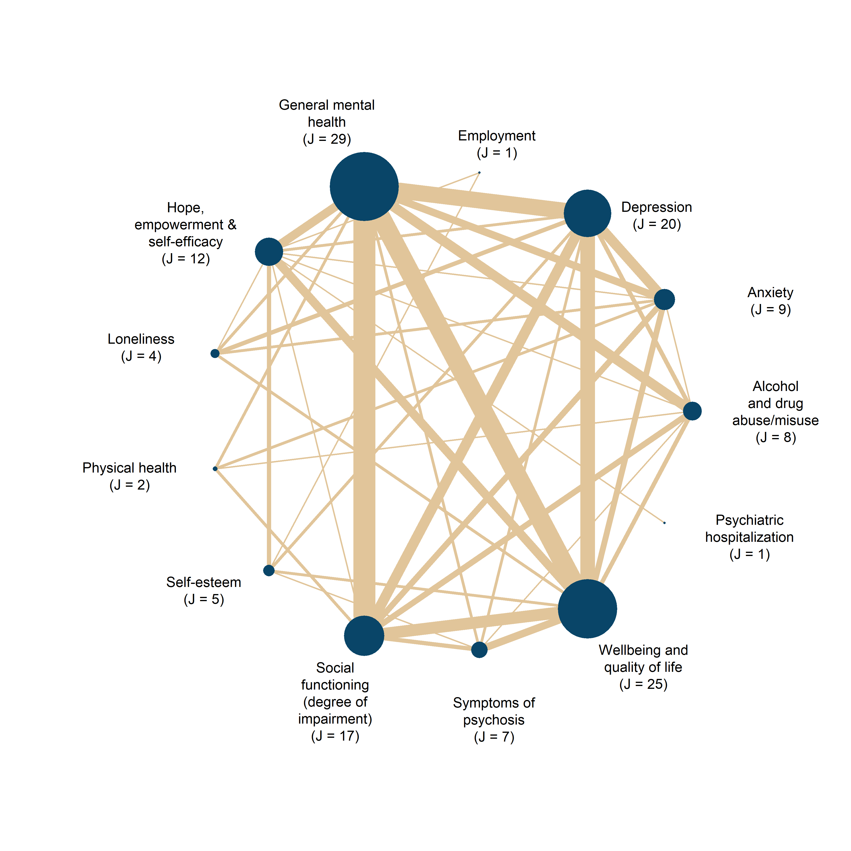

Search methods for identification of studies
Relevant studies were identified through electronic searches of bibliographic databases, governmental and grey literature repositories, hand searched in specific targeted journals, attempts to contact experts, and Internet search engines. The electronic database searches were completed in September 2022, and other resources were completed in July 2024. We searched to identify both published and unpublished literature. The searches were international in scope. Reference lists of included studies used in the meta-analysis were also searched.
We implemented a wide range of search methods and strategies to maximise coverage of relevant references, while simultaneously attempting to reduce different types of bias related to publication and dissemination systems.
Subject terms in the facets were selected according to the thesaurus or index of each database. Keywords were supplied if the search technique provided additional results. Use of truncation and wildcards was used to address English spelling variants.
The different strategies and methods are presented below, and detailed documentation of the searches is available upon request.

Electronic searches
The following databases were searched electronically:
MEDLINE (OVID) 1966 - 2022
EMBASE (OVID) 1974 - 2022
APA PsycINFO (EBSCO) 1800 - 2022
CINAHL (EBSCO) 1981 - 2022
Sociological Abstracts (ProQuest) 1952 - 2022
Social Services Abstracts (ProQuest) 1979 - 2022
SocINDEX (EBSCO) 1908 - 2022
Academic Search Premier (EBSCO) 1975 - 2022
International Bibliography of the Social Sciences (IBSS) (ProQuest) 1951 - 2022
Science Citation Index (Web of Science Core Collection) 1900 - 2022
Social Sciences Citation Index (Web of Science Core Collection) 1990 - 2022
Cochrane Central Register of Controlled Trials (CENTRAL) (1996) – 2022

Searching other resources
In addition to electronic databases, we also searched the following venues:

- Google Scholar—https://scholar.google.com
- Google —https://www.google.com/
- Searches in Google and Google Scholar
- Social Science Research Network — https://papers.ssrn.com/sol3/DisplayAbstractSearch.cfm
- CORE – https://core.ac.uk Internationale repositorier
- Danish National Research Database—http://www.forskningsdatabasen. dk/en
- NORA—Norwegian Open Research Archives—http://nora. openaccess.no/
- Cristin - Current Research Information SysTem In Norway - https://wo.cristin.no/as/WebObjects/cristin.woa/wa/fres?la=no
- SwePub—Academic publications at Swedish universities—http:// swepub.kb.se/
- DIVA - https://www.diva-portal.org/smash/search.jsf?dswid=69

Searches for working papers and conference proceedings in English
SHS Web of Conferences (www.shs-conferences.org) Open Access proceedings in Humanities and Social Sciences
The Social Care Institute for Excellence (SCIE) : www.scie.org.uk/publications/index.asp

Searches for Government Documents
NICE National Institute for Health and Care Excellence www.nice.org.uk

Searches for Dissertations
EBSCO Open Dissertations (https://biblioboard.com/opendissertations/)
Open Access Theses and Dissertations (oatd.org)

Hand Searches
Hand searches were carried out in selected journals:
- BMC Public Health
- BMC Psychiatry
- Journal of Psychosocial Rehabilitation and Mental Health
- Psychiatric Quarterly
- Community Mental Health Journal
- Disability and rehabilitation
- International journal of mental health systems
- Sociology of health and illness
Searches included all issues published in 2022, 2023, and up to May 2024

Citation-tracking
We also checked the references for all identified existing systematic reviews and meta-analyses and all included primary studies.

Contacting experts in the field
We did not contact international experts.

Language restrictions
We reviewed studies published in English, Danish, Swedish, and Norwegian.

Treatment measurement and effect size calculation
Further details about the effect size calculation are given below.
All effect size calculations were conducted using R 4.5.1 and R 4.5.2² and RStudio³. Specifically, we drew substantially on the tidyverse packages⁴ for data manipulation, visualization, and summary statistics of various kinds. We calculated effect sizes from medians and quantiles by using the estmeansd⁵ (version 1.0.1), and we used the metafor package⁶ (version 4.0-8) to aggregate within-study effect sizes not relevant to our moderator analyses.
Moreover, all effect size calculations can be found in the Online Appendix A. In this scheme, we have calculated effect sizes individually for each study. This means that one can press on each study to see the exact methods used to calculate effect sizes for the particular study. We developed this scheme in response to widespread critiques indicating that effect sizes reported in (psychological) meta-analyses are generally difficult to reproduce⁷.

Effect size calculation
We calculated SMDs using the Hedges’ g estimator, which corrects for the small-sample bias inherent in Cohen’s d.⁸ For sensitivity analyses, we also calculated Cohen’s d. All SMDs were coded so that a positive value indicated a beneficial effect of the group-based treatment. Accordingly, effect sizes were reversed for test scales where lower scores indicated better outcomes (e.g., improved condition). For an illustration of this procedure, see Lim et al.⁹. Across all interventions and outcomes, we calculated 349 SMD estimates clustered within 49 studies. All in all, 205 effect sizes from 46 studies captured social reintegration outcomes, while 144 effect sizes from 42 studies captured mental health outcomes. All but two effect sizes represent pretest-adjusted effect sizes.
As we computed effect sizes from the result data deduced from various research designs, estimation techniques, and reporting standards, we applied a wide range of different methods to obtain the relevant statistics for effect size calculation^{10–16}. Specifically, to increase the internal validity and precision of Hedges’ g, we prioritized calculating pretest-/baseline- and/or covariate-adjusted versions of the g metric^{12,14,16,17} . As a further attempt to increase the statistical power of our analyses, we reduced (artificial) within-study variability by aggregating all study results that were reported across subgroups that were not pre-specified in our protocol, as recommended by Vembye, Pustejovsky et al.¹⁸. Specifically, this aims to mitigate chance bias (i.e., that the effect is primarily driven by randomization not adequately balancing all covariates, which often happens in small studies, or when many outcomes are reported) to induce large impacts on the true variation measures. See Sacks et al.¹⁹ for an example of this procedure.
Although participants in the majority of studies had been individually randomized to treatment and control groups, the fact that the intervention was provided in a group format at the same time and space creates dependence among members of the same group, as they share common traits such as receiving treatment from the same therapist/professional, etc. If not accounted for, this yields effect size standard errors that are incorrect. In this regard, we followed the recommendation from the Cochrane Handbook (section 23.1.8¹³) to adjust for clustering arising from this type of clustering caused by group treatment.
Therefore, to ensure comparability between effect sizes²⁰, all effect sizes and the corresponding variance estimates were standardized by the total variance. That is, we computed effect sizes and variance estimates that incorporate both the variation arising from the participant/individual level as well as the cluster level, which means the group-based treatment level. To do so, we cluster-bias adjusted all effect sizes from studies, ignoring the nesting of participants in the given group-based treatment. Only two of the included studies accounted for this issue in the statistics we used for effect size computation (i.e., Haslem et al.²¹; Michalak et al.²²).
In this review, all studies represent so-called partially clustered studies, with clustering arising in the treatment group only. Therefore, we used the cluster-bias methods developed by Hedges and Citkowicz²⁵ that specifically account for this design issue. Because our priority was the covariate-adjusted effect size, and given that Hedges and Citkowicz primarily developed cluster formulas for posttest-only study designs, we integrated their formulas with those presented by WWC¹⁶ and Hedges et al.¹². Vembye²⁶ provides an overview of the exact formulas used can be found at https://mikkelvembye.github.io/VIVECampbell/reference/vgt_smd_1armcluster.html.
A common challenge with cluster-bias adjustments is that they are premised upon intraclass correlation (ICC) values, which are rarely reported in practice. Among the included studies, only three studies (Crawford et al.²⁴; Haslem et al.²¹; van Gestel-Timmermans et al.²³) reported ICC values; otherwise, ICC values were imputed, as suggested by Hedges²⁷ (2007). We imputed ICC values of 0.1 for the main analyses and conducted sensitivity analyses imputing ICC equal to 0.05 and 0.2. For further details, see section ‘Unit of analysis issues’ below.
The final distributions of effect sizes for social reintegration and mental health outcomes, respectively, are presented in Figures S7-S8.
Fig. S7 | Empirical distribution of social reintegration (primary outcome) effect size estimates
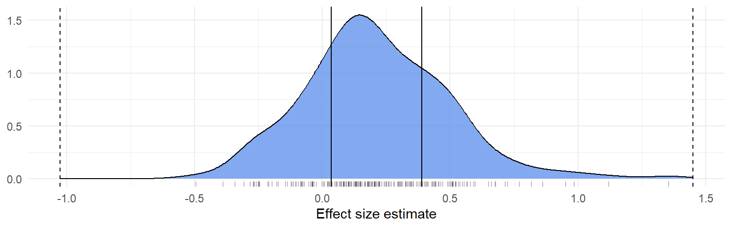
Note: Empirical distribution of social reintegration effect size estimates. Solid vertical lines indicate lower and upper quartiles. Dashed lines indicate the 1st quartile minus 3 times the inter-quartile range and the 3rd quartile plus 3 times the interquartile range. Effect sizes outside of the range of dashed lines would be considered outliers according to Tukey’s²⁸ definition.

Fig. S8 | Empirical distribution of mental health (secondary outcome) effect size estimates
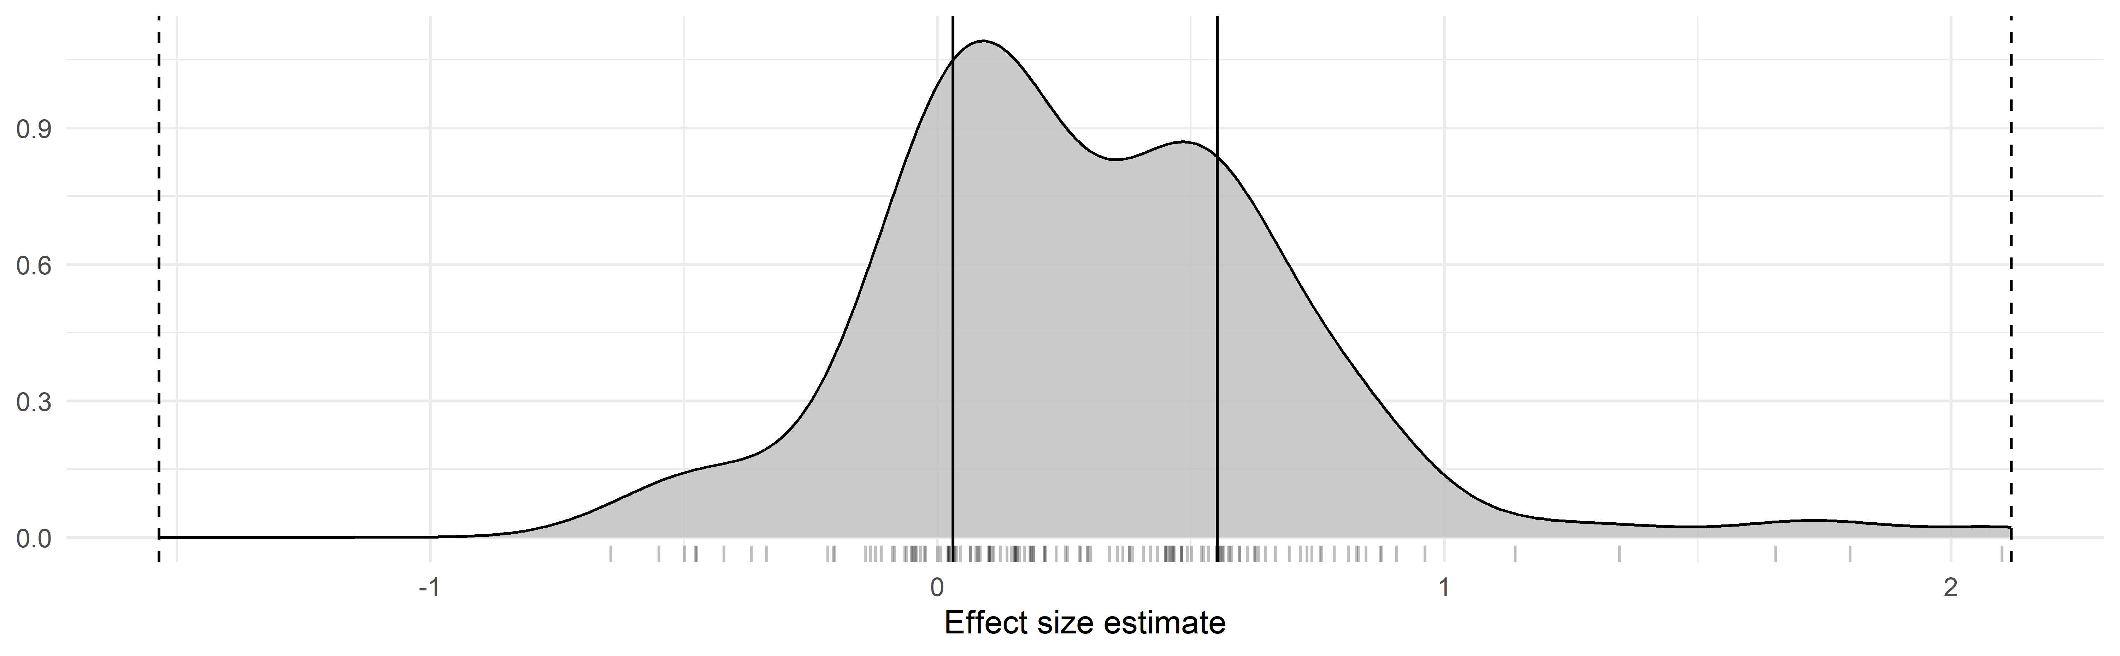
Note: Empirical distribution of mental health effect size estimates. Solid vertical lines indicate lower and upper quartiles. Dashed lines indicate the 1st quartile minus 3 times the inter-quartile range and the 3rd quartile plus 3 times the interquartile range. Effect sizes outside of the range of dashed lines would be considered outliers according to Tukey’s²⁸ definition.

For more detailed visualization across more specific outcomes, see the Online Appendix B, Figures 95 and 96.

Further technical description of the effect size calculation
To describe the above procedure more formally, the Hedges’ g estimator we used can be written as
 | $$g_{t}=κ×\left(\frac{b}{S}\right)×γ$$ | (1)

The subscripted $t$ in (1) indicates that the g metric was standardized by the total variance. $κ$ is the small study corrector, $1-\frac{3}{4*df-1}$, where $df$ is the degrees of freedom, which typically equals $N$ . That is the total sample size of the study. Yet, as all included studies are partially cluster-designed studies, we calculated cluster-adjusted degrees of freedom $(df_{cl})$ as (c.f. Hedges & Citkowicz²⁵, Equation 7):

 | $$df_{cl}=\frac{{\left[\left(N-2\right)\left(1-ρ_{ICC}\right)+\left(N_{T}-n\right)ρ_{ICC}\right]}^{2}}{\left(N-2\right){\left(1-ρ_{ICC}\right)}^{2}+\left(N_{T}-n\right)nρ_{ICC}^{2}+2(N_{T}-n)(1-ρ_{ICC})ρ_{ICC}}$$ | (2)

Where $N$ is given as above, $ρ_{ICC}$ is the intraclass correlation, $N_{T}$ is the sample size of the treatment group, and $n$ is the average cluster size. That is the average sample size of the group-based treatment format. As previously described, we could only obtain empirical values of $ρ_{ICC}$ from three studies. Thus, we most often imputed this value. Whenever possible, we empirically obtained values of $n$ from the included studies. If the average sample size of the group treatment was not reported, we assumed $n=8$. This value equals the median group size for studies that empirically reported this value and reported social reintegration outcomes.
Next, $b$ in Equation (1) denotes the mean difference between the group-based treatment group and the individual control group. Most commonly, we computed $b$ as a difference-in-differences estimate, that is, ${(M}_{T}^{post}-M_{T}^{pre})-{(M}_{C}^{post}-M_{C}^{pre})$, where, $M_{T}^{pre}$,$M_{C}^{pre}$, $M_{T}^{post}$, and $M_{C}^{post}$ represent the pre- and posttest means for the treatment and control groups, respectively. We define this type of effect size as a difference-in-difference (DID) effect size. For 40 studies, we calculated the nominator of Equation (1) from the raw pre- and posttest means.
For five studies (van Gestel-Timmermans et al.²³; Gonzalez & Prihoda²⁹; McCay et al.³⁰; Smith et al.³¹, 2021; Wuthrich & Rapee³²), $b$ was obtained either from repeated ANOVAs or estimated marginal means. Moreover, $b$ was obtained as regression estimates from multi-level regression models for two studies (Haslam et al.²¹; Michalak et al.²²). One study (Gutman et al.³³) provided the raw data. From this data, we estimated pretest-adjusted effects using standardized linear regression. Finally, for one study only (Bond et al.³⁴), we calculated the posttest-only version of $b$, that is $b= {(M}_{T}^{post}-M_{C}^{post}).$
$S$ in Equation (1) represents the pooled standard deviation (SD). Sometimes referred to as the pooled within-group SD³⁵. This was most frequently calculated (i.e., for 318 effect sizes and 43 studies) as $S= \sqrt{\frac{\left(N_{T}-1\right)SD_{T}^{2}+\left(N_{C}-1\right)SD_{C}^{2}}{N_{T}+N_{C}-2}}$, where $N_{C}$ is the sample size of the control group, whereas $SD_{T}$ and $SD_{C}$ represent the SD of the treatment and control group, respectively. Four studies (Haslam et al.²¹; Smith et al.³¹; Wojtalik et al.³⁶; Wuthrich & Rapee³²) did not report posttest SDs. In these cases, we used the pretest standard deviation instead.
For one study (McCay et al.³⁰), where we extracted Cohen’s d estimates calculated by the authors, it was unclear how $S$ is calculated, but we assumed that a pooled SD was used as prescribed for Cohen’s d. From two studies (Gonzalez & Prihoda²⁹; Michalak et al.²²), we extracted the total SD and not the pooled within-study SD. To align this SD measure, we used Equation E.14 from the What Works Clearinghouse’s standard and procedure handbook³⁵ (version 5, p. 168) to convert them to the pooled within-group SD.
For effect sizes based on the GAF (Global Assessment of Functioning), PHQ-9 (Patient Health Questionnaire), and BDI (Beck Depression Inventory) scales, we calculated S as a population-based standard deviation, following the recommendation of Fitzgerald and Tipton¹¹. Specifically, S was estimated by pooling all control group standard deviations. We adopted this approach to increase the generalizability/external validity of the results, as the population-based version of S provides an estimate closer to the population we want to generalize to. We applied this method only to these three scales, as each was reported in at least five studies—the minimum number required for adequately estimating population-based standard deviations¹¹.
Finally, $γ$ in Equation (1) is the small number of clusters adjustment factor¹⁶ that is computed as $1-\frac{\left(N_{C}+n-2\right)ρ_{ICC}}{N-2}$ with all quantities given as previously defined.
Next, a general formula expressing the sample variance ${(V}_{gt})$ of our Hedges’ g estimator can be written as
 | $$V_{gt}=W×ξ+P$$ | (3)

here $W$ is the scaled/standardized sampling variance of $b$ from Equation (1), i.e., ${\left(\frac{se_{b}}{S}\right)}^{2}$, which expresses the contribution of the variability of $b$, whereas $P$ “captures the contribution of the variance of [$S$]—that is, how precisely estimated is the scale [/standard deviation] of the outcome”³⁷. $ξ$ either represents the small number of clusters adjustment factor, $γ$, or the design effect, $η$, depending on whether a study adequately accounted for clustering or not. $η$ is given by $1+\left(\frac{nN_{C}}{N}-1\right)ρ_{ICC}$.
Again, as we extracted data from various research designs, estimation techniques, and reporting standards, we computed $W$ from Equation (3) in several ways. As we most frequently calculated difference-in-differences (DID) effect sizes, we obtained $W$ as $2(1-r)\left(\frac{1}{N_{T}}+ \frac{1}{N_{C}}\right)$, where $r$is the pre-posttest correlation. Although $r$ is usually not reported in primary studies, this can be calculated from commonly reported measures. For nine studies^{23,33,38–44}, we could obtain $r$ directly from the study or calculate $r$ either using the equation from the Cochrane Handbook¹³ (section 6.5.2) or Equation 31 from Wilson¹⁵. As described by Pustejovsky¹⁴, an equivalent alternative to estimating $W$ for covariate-adjusted effect sizes is to use $t$ of $F$ test values, thus $W=\frac{g_{t}^{2}}{F}={\left(\frac{g_{t}}{t}\right)}^{2}.$ We used either $t$ or $F$ values from seven studies^{22,40,45–49} reporting difference-in-difference and one study²⁹ reporting repeated ANOVA estimates. If either the t/F test seemed flawed or yielded a larger variance estimate relative to the DID variance estimator, we used the DID variance estimator and imputed $r$ when necessary (see Druss et al.⁵⁰; James et al.⁵¹).
On this matter, Hedges et al.¹² (2023) suggest using test-retest reliability values of a given outcome scale whenever it is impossible to compute $r$. We imputed test-retest reliability measures as proxies for $r$ in two studies (Cano-Vindel et al.⁵²; Morton et al.⁵³). For studies where we were not able to apply any of the above methods, we imputed $r=0.5$. Thus, $W$ reduces to $\left(\frac{1}{N_{T}}+ \frac{1}{N_{C}}\right)$, which equals $W$ computed for posttest-only effect sizes.
For three studies, we calculated $W={\left(\frac{se_{b}}{S}\right)}^{2}$, where $se_{b}$ is the standard error of $b,$ typically, representing the covariate-adjusted mean difference between the treatment and control group. In three studies using ANCOVA-like estimation (i.e., repeated ANOVA and estimated marginal means) methods (McCay et al.³⁰; Smith et al.³¹; Wuthrich & Rapee³²), we estimated $W=(1-r^{2}) \left(\frac{1}{N_{T}}+ \frac{1}{N_{C}}\right)$.
For all covariate-adjusted effect size estimates, we calculated $P$ in Equation (3) as $\frac{g_{t}}{2(df-q)}$, $g_{t}$ and $df$ are defined in Equations (1) and (2), and $q$ is the number of covariates. For posttest-only effect sizes $q=0$, whereas for pretest/baseline-only adjusted effect sizes $q=1.$ We did not adjust $V_{gt}$ for small sample bias (i.e., multiplying $κ^{2}$ with Equation 3), as Hedges et al.¹² recommend not doing so.

Further details about the data synthesis

Unit of analysis issues
The unit of analysis of this review was the effects of group-based intervention on the individual participants. However, the fact that group-based interventions are provided to the participant in a group format at the same time and space likely creates dependence/clustering among/of participants. That is, the treatment effects for participants in the same group are more similar compared to other individuals who are not a part of the particular group. This breaks the classical statistical assumption of independence⁵⁴. Thus, if this type of clustering is not accounted for, the average individual treatment effects will appear to be more certain than they actually are (i.e., the standard errors will be underestimated). As mentioned in the previous section, we, therefore, cluster-biased corrected all studies to account for this dependence of participants from the same group, which in this case is only an issue in the treatment group.
Although cluster-bias correction of treatments received in groups is recommended by Higgins, Eldridge, et al.¹³, “Weiss et al. (2016) indicate that both adjusting and not adjusting are likely to yield biased standard errors in primary studies (over- and underestimated, respectively)”⁵⁵. Therefore, to accommodate this issue, we conducted a sensitivity analysis, using a non-cluster-adjusted version of the g estimator. That is, we did not add the $γ$ and $ξ$ factors to Equations (1) and (3), respectively.
As the statistical method we used for cluster adjustments²⁵ has not been implemented in any standard software, we developed our own R package VIVECampbell²⁶, in which we implement cluster-bias adjustments when there is clustering in one treatment group only across various effect size estimation techniques.

Other unit of analysis issues
Our protocol states that we intended to analyze posttest (i.e., effects measured one year or less after the end of the intervention) and follow-up (i.e., effects measured more than 1 year after the end of the intervention) effects separately to avoid unit-of-analysis errors. However, we did not detect any follow-up effects. As an exploratory sensitivity analysis, we investigated whether the measurement timing within the first year could explain differences between effect sizes.

Criteria for the determination of independent findings (dependent effect sizes)
As the majority of the included studies contribute multiple effect sizes, the final datasets contain dependencies among the computed effect sizes. The primary dependency structure we detected in our datasets pertained to the correlated effects dependency structure, where studies report multiple outcome results from the same or partially the same sample of participants. Most commonly, studies (30 for social reintegration outcomes and 36 for mental health outcomes) reported results for the same participants across different outcomes and/or time points. As noted in Table 1 in the paper, three studies also created correlated dependencies by comparing multiple treatment groups to a single control group.
We did not have any studies creating the so-called hierarchical effects dependency structure, in which the dependency arises from outcomes reported across distinct, non-overlapping samples. Finally, 12 (social reintegration) and 8 (mental health) studies reported a single effect size only.
This type of complex dependency requires advanced meta-analytical techniques to avoid the production of overly optimistic results. To address this, we used the correlated hierarchical effects (CHE) model family (Pustejovsky & Tipton, 2025). These models account simultaneously for both hierarchical and correlational dependence in meta-analytic data. To guard against model misspecification, we employed either robust variance estimation^{56,57} (RVE) or cluster bootstrap methods^{58–60}. RVE was used when estimating standard errors for single coefficients in the main analyses, whereas bootstrap methods were applied for Wald test statistics and for publication bias analyses. These applications are described in more detail in later sections.
A challenge when working with dependent effect size data is that the true dependence is largely unknown, requiring the meta-analytist to make arbitrary guesses about the true correlation among the dependent effect size estimates. For the three multi-treatment, however, we were able to asymptotically estimate the correlation among the effect sizes using the vcalc function from the metafor, which implements formulas from Gleser and Olkin⁶¹ and Wei and Higgins⁶². For all other cases, we assumed a constant within-study correlation of 0.8, as specified in our protocol.
To capture this combination of empirically estimated and assumed correlations, all fitted models are denoted with the prefix PE (Partially Empirical), following Pustejovsky & Tipton⁶³. For example, the CHE model is denoted PECHE, standing for Partially Empirically Correlated Hierarchical Effects.
To provide a more profound understanding of the dependency structure of our data, we applied the ‘preliminary data analysis for meta-analysis of dependent effect sizes’ (PRIMED) workflow.⁶⁴ On the one hand, this helped us to illustrate and visualize both the hierarchical and correlational structure of the dataset, with effect sizes nested within studies and with studies reporting on multiple eligible outcomes. On the other hand, it helped us detect any coding errors that were not caught during our quality checks. All the PRIMED analyses can be found in the Online Appendix B at https://osf.io/s2j9a/files.

Dealing with missing data
According to Pigott⁶⁵, missing data in meta-analyses arises for three main reasons: (1) missing studies, meaning that some studies cannot be detected for various reasons; (2) missing effect sizes within a study, for example, because certain outcomes are not reported or because statistical measures needed to calculate effect sizes are unavailable; and (3) missing predictor variables, that is, study, sample, or outcome characteristics that researchers wish to use to predict differences in effect sizes but which are not reported. As reasons (1) and (2) primarily reflect publication and reporting biases, we describe how these issues are addressed in the section entitled ‘Assessment of reporting biases’ below. A further type of missingness pertains to attrition of participants in the study sample. The consequences of this type of issue are assessed in our risk of bias assessment.
For the latter issue (3), concerning missingness on the predictor variables described in our protocol, we used mean imputation to recover missing values. Although this was not prespecified in our protocol and is not considered to be a state-of-the-art management of the missingness, we did so because we experienced having a maximum of one missing study across all moderator variables prescribed in the protocol. Specifically, we could not obtain information about the average number of males in the study sample for Gordon et al.⁴⁷, prompting us to impute means on the ‘average percent males in sample’ variable related to three social reintegration effect size estimates and one mental health effect size estimate, respectively. Further, we could not back out the number of intervention sessions for Somers et al.⁴⁴, causing us to impute means on the ‘total number of sessions’ variable related to four social reintegration effect size estimates and one mental health effect size estimate, respectively.
As the number of missing values was so few, we found it unnecessary to use more sophisticated techniques such as multiple imputation. This would moreover unnecessarily complete the reliable computation of the cluster robust standard errors and the embedded degrees of freedom (see Vembye et al.⁶⁶, for a description of this problem).

Assessment of heterogeneity
We primarily assessed heterogeneity with the measures of between-study ($τ$) and within-study ($ω$) SDs, along with the total variation between true effects. That is $σ_{T}=\sqrt{\left(τ^{2}+ ω^{2}\right)}$. We used the restricted maximum likelihood versions of $τ$ and $ω$. For the overall average effect size estimations, we reported $I^{2}$.⁶⁷ However, this should not be interpreted as a key indicator of heterogeneity, as this is just a measure of the ratio between the true variation between effects and the sampling error⁶⁸. For the overall average effect size estimates, we also report Q statistics and 67% prediction intervals. With inspiration from Treves et al.⁶⁹, we chose to use a 67% prediction interval because this interval covers the most typical range of observations that one would expect to see in a new study. In fact, it represents 2/3 of the most likely effect sizes expected to be seen in a new study.

Overall average effect – PECHE-RVE
As we experienced various types of dependencies in our data, we derived the overall average effects for social integrational and mental health outcomes, using the partially empirical correlated-hierarchical effects (PECHE-RVE) model⁶³, as this model can handle various types of dependencies among effect sizes. Specifically, this model accounts for the hierarchical data structure, with effect sizes nested within studies, allowing us to obtain heterogeneity measures at both the study-level and the effect size-level. This provides valuable diagnostic information about at what levels unexplained heterogeneity might be explained. We used restricted maximum likelihood to estimate the between-study ($τ^{2}$) and within-study ($ω^{2}$) heterogeneity^{70,71}.

Moreover, the model accounts for correlation among the effect size standard errors, either by imputing or estimating the covariance between within-study effect sizes. In our data, we were able to estimate the covariance for some within-study effects. However, for the majority of the effect sizes, we estimate the study's variance-covariance matrix by imputing $ρ=0.8$, as specified in our protocol.

As previously described in the ’Criteria for the determination of independent findings’ section, we used robust variance estimation (RVE) to guard against model misspecifications.

Further model details and notation for PECHE-RVE
To explicate the statistical models used in this review, consider that our data represent a collection of $J$ studies, each contributing $k_{j}≥1$ effect size estimate. Let $T_{ij}$ be the effect size estimate $i$ ($i=1…, k_{j}$) from study $j$ ($j=1, …, J$) with known and fixed sampling variance $s_{ij}^{2}$. Then let $x_{ij}$ denote a row vector of 𝑝 covariates and 𝛽 denote a vector of 𝑝 regression coefficients. In formal parlance, the PECHE working model can be written as:

 | $$T_{ij}=x_{ij}β+u_{j}+v_{ij}+e_{ij}$$ | (5)

For the intercept-only model, estimating the overall average effect, $x_{ij}$ reduces to a row vector of 1’s and $β$represents the overall average effect. In this model, it is assumed that the study-level and within-study random effects follow and normal distribution with $u_{j}\sim N\left(0, τ^{2}\right)$ and $v_{ij}\sim N\left(0, ω^{2}\right).$ Also, the sampling errors $e_{ij}=T_{ij}-β$ are assumed to follow a normal distribution with $e_{ij}\sim N(0, s_{ij}^{2})$.

To account for correlated dependency, the model assumes that all within-study effects are equally correlated, thus that $Cov\left(e_{ij}, e_{hj}\right)=ρs_{ij}s_{hj}$ for effect sizes $i≠h$within study $j$. As the correlation $ρ$ among within-study effect sizes is usually unknown, it the often imputed and assumed to be constant across studies. However, when studies included multiple treatment groups compared to the same control group, the covariance between within-study effects can be asymptotically approximated. We used this approach when estimating the variance-covariances for the three studies with multiple treatment groups. We thereby used a mixture of empirically known and unknown covariance estimates.

Subgroup analysis and investigation of heterogeneity
To investigate whether focal moderators could explain the true difference in effect sizes, we conducted a series of subgroup and moderator analyses. These analyses fall into three categories: 1) analyses regarding theoretically relevant categorical moderators, 2) analyses of methodological and bias-related categorical moderators, and 3) analyses concerning theoretically relevant continuous moderators. For the first and second sets of analyses, we used the partially empirical subgroup correlated-effects plus (PESCE+[RVE]) model⁶³. For the third category, we relied on the PECHE-RVE model, as presented in Equation (5). To examine whether mental health and social reintegration effects tend to covary, we fitted the partially correlated and multivariate effects plus model (PECVME; see Pustejovsky & Tipton⁶³, first version on OSF).

Specifically, we applied the PESCE+ model combined with RVE and cluster wild bootstrapping when investigating binary or categorical moderators. Generally, this amounts to conducting individual PECHE meta-analyses across each subgroup while accounting for studies contributing $k_{j}≥1$ effects to $C≥1$ subgroups (i.e., the model handles dependent effect sizes). Importantly, this allows us to estimate reliable Wald test p-values with adequate statistical properties. To test whether single-subgroup effects were statistically distinct from null, we used RVE (i.e., the HTZ test), whereas we used cluster wild bootstrapping to estimate Wald test p-values comparing differences between the subgroup effects. In line with the estimation of the overall average effect size, we fitted this model to include heterogeneity at both the effect and study levels (indicated by the + sign).

List of moderators
As per protocol, the moderator analyses included the following factors:

Theoretical factors:
- The measured outcome (e.g., alcholhol and drug use, social functioning, well-being and quality of life)
- The sample characteristics including:
  - samples with vs. without participants with schizophrenia,
  - the average percentage og males in the sample,
  - the average age of the participants.

- The type of intervention (cognitive-behavioral therapy [CBT] vs. other types of interventions).
- The number of intervention sessions
- The duration of the intervention

Methodological factors
- The preregistration status
- The type of test (clinician-rate vs. self-reported)
- The analytical strategy (ITT vs. TOT)
- The research design ([C]RCT vs. QES)
- The type of control group (individual treatment vs. treatment as usual (TAU and waitlist)
- The overall risk of bias status (high vs. low/moderate overall risk of bias
- The timing of the measurement after the end of the intervention.

Across all of the above-listed meta-regression analyses, we fitted models with and without controlling for other covariates. In the covariate-adjusted models, we controlled for 1) the type of outcome, 2) whether the sample included participants with schizophrenia, 3) whether the group-based intervention was based on CBT, 4) preregistration status, 5) type og test, 6) the analytical strategy, 7) the research design ([C]RCT vs. QES), 8) type of control group, 9) the risk of bias rating, 10) average age of study sample, 11) percentage of males in sample, 12) number of session per week, 13) length of intervention (duration), and finally 14) measurement timing. To guard against multicollinearity, we only added covariates that did not show intercorrelations above 0.5. Consequently, we did not add the percentage of males and the number of sessions indicators, as these factors were highly correlated with the sample composition and duration, respectively, for social reintegration outcomes. For models including mental health outcomes, we did not add the risk of bias, control group, and number of sessions indicators to the models, as these factors were highly correlated with the research design, age, and duration, respectively. Find the full correlation matrix used for the selection of variables in the Appendix B Tables 36 and 41.

To ease and ensure correct interpretation of overall average subgroup means from the PESCE+ model⁷², we centered all bivariate and continuous control variables. For the former set of variables, we used mean-centering, whereas we used rounded median-centering for the continuous variables. When using the type of outcome measure as control, we added a dummy variable individually for each outcome to the model.

Further model details and notation for PESCE+
The PESCE+[RVE] model accounts for dependent effect sizes by assuming that effects from the same studies falling into the same subgroup are correlated, whereas effects falling into different subgroups are assumed to be uncorrelated. Despite more advanced models being available that account for correlations between effects from the same study appearing across different subgroups, these models have only been shown to perform adequately under specific data structures, which were only present at the most generic level of the data. Therefore, we used the PESCE+[RVE], which formally takes the following form

 | $$T_{ij}=\sum_{c=1}^{C}{m_{ij}^{c}\left(x_{ij}β_{c}+u_{cj}+v_{cij}\right)+e_{ij}}$$ | (6)

Here, $m_{ij}^{c}$ $\left(m_{ij}^{1}…m_{ij}^{C}\right)$is an indicator of whether the effect size $i$from study $j$ falls in subgroup $c$ for all $c=1…C$. If so, $m_{ij}^{c}=1$, otherwise $m_{ij}^{c}=0$. The model is based in the following assumptions: $u_{cj}\sim N(0, τ_{c}^{2})$, $v_{cij}\sim N(0, ω_{c}^{2})$, and $e_{ij}\sim N(0, s_{ij}^{2})$, $Cov\left(u_{cj}, u_{bj}\right)=0$, $Cov\left(v_{cij}, v_{bij}\right)=0$, and $Cov\left(e_{ij}, e_{lj}\right)=ρs_{ij}s_{lj}\sum_{c=1}^{C}{m_{ij}^{c}m_{lj}^{c}},$thereby $Cov\left(e_{ij}, e_{hj}\right)=0$ when $m_{ij}^{c}≠m_{hj}^{c}$.

Examination of covariation between social reintegration and mental health outcomes
As the majority of studies both reported on social reintegration and mental health outcomes, we used, as mentioned above, the PECVME model to statistically examine whether group-based interventions with larger impacts on social reintegration outcomes also tended to have greater impacts on mental health outcomes. The major difference between PECMVE and PESCE is that the PECMVE model allows effects from the same studies falling in different subgroups to be correlated. The model takes the following form

 | $$T_{ij}=x_{ij}β \sum_{c=1}^{C}{\left({m_{ij}^{c}u}_{cj}+{m_{ij}^{c}v}_{cij}\right)+e_{ij}}$$ | (7)

where $u_{cj}\sim N(0, τ_{c}^{2})$, $v_{cij}\sim N(0, ω_{c}^{2})$, and $e_{ij}\sim N(0, s_{ij}^{2})$, $Cov\left(u_{cj}, u_{bj}\right)=ψ_{bc}τ_{b}τ_{c}$, $Cov\left(v_{cij}, v_{bij}\right)=$ $ζ_{bc}ω_{b}ω_{c}$, and $Cov\left(e_{ij}, e_{lj}\right)=ρs_{ij}s_{lj}$. $ψ_{bc}$ and $ζ_{bc}$ are the correlations between the random effects at the study and effect size level, respectively.

Sensitivity analysis
To test the robustness of our results, we conducted a range of sensitivity analyses. First, we tested if our results were sensitive to the assumed correlation among within-study effects, as this assumption can impact some parts of the model estimation. Specifically, we reestimated all results by setting $ρ=0, .2, .4, .6., .9$. Note, the first specification amounts to fitting a classical multi-level meta-analysis model^{73,74} (MLMA-RVE).

Second, we ran sensitivity analyses across different types of effect size metrics. That is, we reestimated all results using a covariate/pretest-adjusted version of both Cohen’s $d$ and Hedges’ $g$ (i.e., without adjusting for clustering), $g_{t}$ (c.f. Equation 1) standardized by its original standard deviation and not the population-based version, and a posttest-only version of $g_{t}$. We also tested the sensitivity across different assumptions of the interclass correlation (ICC) used to cluster-bias-adjust effect sizes, setting $ICC=0.05, 0.2.$
Finally, we investigated whether the impact of removing high-risk of bias effect and non-randomized studies on our results. We did not examine the impact of outliers, as we did not find any one as defined as effect sizes falling more than three times the interquartile range below the first quartile or above the third quartile^{28,64}, see Figures S7 and S8.

Assessment of reporting biases
We conducted a range of complementary publication bias and/or small study effects tests (henceforth publication bias tests), as no publication bias test clearly outperforms all other methods. Also, this follows the general recommendations for publication bias testing in meta-analysis^{76–79}. Specifically, we conducted the following tests separately for the social reintegration (primary outcome) and mental health (secondary outcome) data:

- Bootstrap versions of the newly developed hybrid extended meta-analysis (HYEMA) tests⁸⁰
- Worst-case sensitivity analysis tests⁸¹
- p-uniform* tests⁸²
- Robust and adjusted version of the partially empirically correlated-hierarchical effects model that incorporates inverse sampling covariance weights (PECHE-ISCW)^{77,83}
- Robust and adjusted versions of PET/PEESE, incorporating ISCW⁷⁷
- The newly developed bootstrapped step-function selection models for meta-analysis of dependent effect sizes⁶⁰

On the one hand, we chose these tests because they have shown the most promising statistical properties in the simulation studies embedded in the cited studies above, as well as shown in independent evaluations of publication bias methods^{76,79}. On the other hand, Chen and Pustejovsky⁷⁷ and Pustejovsky, Citkowicz et al.⁶⁰ have shown that regression-based methods (such as PECHE-RVE-ISCW and PET/PEESE-RVE-ISCW) are generally better relative to selection models at detecting publication biases when selection is weak, whereas the selection models clearly outperform regression-based methods in the presence of moderate to strong selection in effect sizes. We, therefore, aimed to include a mixture of publication bias tests that function well under different levels of selective reporting.

To differentiate between publication bias and systematic and substantial differences between effect sizes, we conducted two types of tests, where we adjusted subgroup effects for publication bias. Specifically, we adjusted subgroup effects for publication bias for preregistration status and outcome type. As not all publication bias tests can be used for correcting subgroup effects, we only used a subset of the above-listed tests. Find information on the exact models used for this type of publication bias adjustment in the next section.

Across all models, despite the worst-case meta-analysis models, we used a modified version of the standard error and variance presented in Equation (3). More precisely, we defined the modified version of the standard error and variance as follows:

 | $V_{gt}^{mod}= W×ξ$and $SE_{mod}= \sqrt{V_{gt}^{mod}}$. | (4)

As described by Pustejovsky and Rodgers³⁷, this approach is necessary to avoid the artificial correlation between SMD effect size estimates and their sampling variance, which arises because SMD estimates are used to calculate $P$ in Equation (3). For a better understanding of the relative difference between $V_{gt}^{mod}$ and $V_{gt}$, see Figures 91 and 92 in Appendix B. We did not use modified standard errors in the worst-case meta-analysis, as it is intended to represent a sensitivity analysis that replicates the main analysis, just without including effect sizes that affirm one's non-null hypothesis and are statistically significant.

Visualization
For visualization purposes, we applied contour-enhanced funnel plots⁸⁴, which aim to depict the relationship between the effect sizes and their estimated standard errors. In these plots, we included the estimated slope from the robust Egger’s regression tests⁸⁰, and colored the effect size estimate by their overall risk of bias assessment. We both visualize funnel plots of the study and effect size levels. For the study-level plots, we averaged all within-study effect sizes, assuming a constant between-effects correlation of 0.8. As all of our risk of bias assessments were conducted at the effect size level, we did not color the average effect sizes in study-level plots. Find funnel plots including study-level assessments in the Online Appendix E.

Selective reporting and preregistration
A special feature of our data is that approximately half of the included studies (22 of 46 studies in the social integrational data and 20 out of 42 studies in the mental health data) were preregistered. In preregistered studies, one could expect that publication bias is either completely absent or at least much less pronounced compared to conventional, non-preregistered studies. For this type of effect size data, it has recently been suggested not to correct preregistered studies for publication bias⁸⁰ or to model this factor⁶⁰. In line with these recommendations, we assessed publication bias by only adjusting non-preregistered studies or by adding a centered dummy variable for preregistration status to the given publication bias model. Centering of binary variables follows the recommendation forwarded by Fisher and Tipton⁷². Moreover, we depicted funnel plots separately for preregistered and non-preregistered studies.

Model-specific details for publication bias tests

Cluster bootstrap HYEMA
As the only test, HYEMA provides average effect size estimates where only effect sizes from non-preregistered studies are adjusted for publication bias. Although this test has shown promising performance⁸⁰, it has only been evaluated under the assumption of independence among effect sizes (i.e., assuming all studies contribute one effect size only). To overcome this issue and to control the nominal Type I error rate, we cluster-boostrapped this model⁵⁹. For the bootstrap models, we calculated the percentile confidence intervals, as these have shown the most promising performance in other applications⁶⁰.

Furthermore, we used the HYEMA model to adjust outcome moderator effects for publication bias. For multi-constrast tests, investigating whether effect sizes differed across different types of outcome, we computed bootstrap Wald test p-values defined as

$$p=\frac{1}{R}\sum_{r=1}^{R}{I(F^{r}>F)}$$

Where R is the total number of cluster bootstrap replications, and F is the naïve F-test. We used similar formulas to calculate the naïve F-test, similar to those implemented in the rma() function in metafor. Across all of these tests, we used $R=1999$.

p-uniform*
The p-uniform* method intends to adjust for publication bias by estimating the overall average effect size that makes the distribution of p-values in the data as uniform as possible. Apparently, a downside of the p-uniform* method is that it is based on the assumption of independence among effect sizes, which by design makes it miscalibrated when applied with dependent effect sizes. Nonetheless, Chen and Pustejovsky⁷⁷ showed that the method performs well even in dependent effect size data, which is the main reason why we included this method. Yet, this method has only been developed to adjust the overall average mean effect, and we therefore only used it for this purpose.

Worst-case meta-analysis
The worst-case meta-analysis is a sensitivity analysis in which all positive and statistically significant effect sizes were excluded, under the extreme assumption that all represent false positives. If the overall average effect remains statistically significant and substantial in size, this provides strong evidence that publication bias is not the primary factor driving the effect(s). We used this type of analysis to re-estimate the overall average effect size as well as subgroup effects across preregistration status and types of outcome. For the latter analysis, we controlled for preregistration status.

Partly to ease comparison between publication bias tests and partly to ease the presentation of these tests, we only fitted these models using the PECHE-RVE model as presented in Equation (5) above^{63,85}. For the subgroup test, this model type slightly differs from the one used in the main analysis. To align the models, we also fitted moderator models using the same model as in the main subgroup analyses. These tests can be found in the publication bias script in the Online Appendix E.

(PE)CHE-RVE-ISCW
Next, we used the newly developed PECHE-RVE-ISCW model to test for publication bias⁷⁷. The key feature of this model relative to the original CHE-RVE model (see Equation 5) is that it incorporates weights that are based on inverse sampling variance estimates and the assumed covariance between these estimates. When using the modified version of the variance described in Equation (4), this corresponds to fixed-effect weighting, or more precisely, weighting by the inverse of the effective sample sizes and the assumed covariance among these.

To guard against model mis-specification and adjust for small sample issues, we used RVE, or more precisely, the robust HTZ for single-contrast tests⁸⁶. This type of test was used for the overall average effect size and single-subgroup effects estimations, following the recommendation by Joshi, Pustejovsky et al.⁵⁸. When estimating multiple-contrast hypothesis tests, we estimated cluster wild bootstrap Wald test p values⁵⁸.

We used this test to adjust for publication bias in both the overall average effect size and the moderator effects across preregistration status and outcome types

PET/PEESE-RVE-ISCW
The PET/PEESE-RVE-ISCW models we used had the same shape as the PECHE-RVE-ISCW model, with the only exception that we either added the modified sampling variance (PEESE; precision-effect estimator with standard error) or the modified standard error (PET; precision-effect test) presented in Equation (4) as a predictor in the models. As with the PECHE-CHE-ISCW model, we used this test to adjust the overall average effect size as well as the moderator effects across preregistration status and types of outcome. Differently, and in addition to the PECHE-CHE-ISCW model, we also controlled for the preregistration status when estimating the overall average effect.

It has been recommended by Stanley and Doucouliagos⁸⁷ that “[w]hen the PET test is not rejected, meaning that the average effect is not statistically distinguishable from zero, then the PET intercept is used for estimating the adjusted average effect. However, if the PET test is rejected and the average effect is statistically distinct from zero, the PEESE is used for estimating the adjusted average effect”⁷⁷. We followed this decision rule when re-estimating the overall average effect with the PET/PEESE models. For subgroup models, we used the PET-RVE-ISCW only, as the decision rule was not clearly defined in this context.

Cluster bootstrap selection models
As selection models have shown promise across a range of simulations^{60,76,77,83}, we applied two versions of these types of models. That is, we used the three-parameter selection model (3PSM) and the four-parameter selection model (4PSM). The former included a single parameter, describing the “likelihood of non-affirmative effect sizes being observed relative to affirmative effect sizes.“⁷⁷. For this model, we set the step parameter to 0.025, amounting to the threshold of a classical one-sided p-value. The latter model included two-step parameters, which we set to .025 and 0.50. This allowed for modeling different probabilities for non-significant effect sizes, conditional on the direction of the effect.
To account for dependencies in our effect size data, we used cluster bootstrap selection models⁶⁰. Specifically, we fitted these models using the composite marginal likelihood (CML) estimator with two-stage bootstrapped percentile confidence intervals based on 1999 re-sampled replicates, as this model has shown the best performance relative to other estimators and confidence intervals (see Figures 4 & 5 in Pustejovsky, Citkowicz, et al.⁶⁰).
As with the PECHE-RVE-ISWC model, we used this test to adjust for publication bias in both the overall average effect size and the moderator effects across preregistration status and outcome types. In the outcome model, we controlled for the preregistration status.

Reference
1. Fernández-Castilla, B. et al. Visual representations of meta-analyses of multiple outcomes: Extensions to forest plots, funnel plots, and caterpillar plots. Methodology 16, 299–315 (2020).
2. R Core Team. R: A language and environment for statistical computing. Preprint at (2022).
3. RStudio Team. RStudio: Integrated development for R. RStudio Inc Boston MA https://www.rstudio.com/ (2015).
4. Wickham, H. et al. Welcome to the Tidyverse. J. Open Source Softw. 4, 1686 (2019).
5. McGrath, S., Zhao, X., Steele, R. & Benedetti, A. estmeansd: Estimating the sample mean and standard deviation from commonly reported quantiles in meta-analysis. CRAN Contrib. Packag. (2019).
6. Viechtbauer, W. Conducting meta-analyses in R with the metafor package. J. Stat. Softw. 36, 1–48 (2010).
7. Maassen, E. et al. Reproducibility of individual effect sizes in meta-analyses in psychology. PloS One 15, e0233107 (2020).
8. Hedges, L. V. Distribution theory for Glass’s estimator of effect size and related estimators. J. Educ. Stat. 6, 107–128 (1981).
9. Lim, J. E. et al. Benefits of social cognitive skills training within routine community mental health services: Evidence from a non-randomized parallel controlled study. Asian J. Psychiatry 54, 102314 (2020).
10. Borenstein, M. & Hedges, L. V. Effect sizes for meta-analysis. in In H. Cooper, L. V. Hedges, & J. C. Valentine (Eds.), The handbook of research synthesis and meta-analysis (3rd ed., pp. 207–242). Russell Sage Foundation West Sussex (2019).
11. Fitzgerald, K. G. & Tipton, E. Using Extant Data to Improve Estimation of the Standardized Mean Difference. J. Educ. Behav. Stat. 50, 128–148 (2025).
12. Hedges, L. V., Tipton, E., Zejnullahi, R. & Diaz, K. G. Effect sizes in ANCOVA and difference-in-differences designs. Br. J. Math. Stat. Psychol. 76, 259–282 (2023).
13. Higgins, J. P. T., Eldridge, S., Li, & T. Including variants on randomized trials. in In J. P. T. Higgins, J. Thomas, J. Chandler, M. S. Cumpston, T. Li, M. Page, & V. Welch (Eds.), Cochrane handbook for systematic reviews of interventions (2nd ed., pp. 569–593). Wiley Online Library (2019). doi:10.1002/9781119536604.
14. Pustejovsky, J. E. Alternative formulas for the standardized mean difference. https://www.jepusto.com/alternative-formulas-for-the-smd/ (2016).
15. Wilson, D. B. Formulas used by the ‘Practical Meta-Analysis Effect Size Calculator’. (2016).
16. WWC. Supplement document for Appendix E and the What Works Clearinghouse procedures handbook, version 4.1. Inst. Educ. Sci. https://ies.ed.gov/ncee/wwc/Docs/referenceresources/WWC-41-Supplement-508_09212020.pdf (2021).
17. Morris, S. B. Estimating effect sizes from pretest-posttest-control group designs. Organ. Res. Methods 11, 364–386 (2008).
18. Vembye, M. H., Pustejovsky, J. E. & Pigott, T. D. Conducting power analysis for meta-analysis with dependent effect sizes: Common guidelines and an introduction to the POMADE R package. Res. Synth. Methods 15, 1214–1230 (2024).
19. Sacks, S., McKendrick, K., Vazan, P., Sacks, J. Y. & Cleland, C. M. Modified therapeutic community aftercare for clients triply diagnosed with HIV/AIDS and co-occurring mental and substance use disorders. AIDS Care 23, 1676–1686 (2011).
20. Taylor, J. A., Pigott, T. D. & Williams, R. Promoting knowledge accumulation about intervention effects: Exploring strategies for standardizing statistical approaches and effect size reporting. Educ. Res. 51, 72–80 (2021).
21. Haslam, C. et al. GROUPS 4 HEALTH reduces loneliness and social anxiety in adults with psychological distress: Findings from a randomized controlled trial. J. Consult. Clin. Psychol. 87, 787–801 (2019).
22. Michalak J, Schultze M, Heidenreich T, & Schramm E. A randomized controlled trial on the efficacy of mindfulness-based cognitive therapy and a group version of cognitive behavioral analysis system of psychotherapy for chronically depressed patients. J. Consult. Clin. Psychol. 83, 951–963 (2015).
23. van Gestel-Timmermans, H., Brouwers, E. P. M., van Assen, M. A. L. M. & van Nieuwenhuizen, C. Effects of a peer-run course on recovery from serious mental illness: a randomized controlled trial. Psychiatr. Serv. 63, 54–60 (2012).
24. Crawford, M. J. et al. Group art therapy as an adjunctive treatment for people with schizophrenia: multicentre pragmatic randomised trial. Bmj 344, (2012).
25. Hedges, L. V. & Citkowicz, M. Estimating effect size when there is clustering in one treatment group. Behav. Res. Methods 47, 1295–1308 (2015).
26. Vembye, M. H. VIVECampbell: Functions for Campbell reviews in VIVE. GitHub (2024).
27. Hedges, L. V. Effect sizes in cluster-randomized designs. J. Educ. Behav. Stat. 32, 341–370 (2007).
28. Tukey, J. W. Exploratory Data Analysis. (Pearson Modern Classic, 1977).
29. Gonzalez, J. M. & Prihoda, T. J. A Case Study of Psychodynamic Group Psychotherapy for Bipolar Disorder. Am. J. Psychother. 61, 405–422 (2007).
30. McCay, E. et al. A randomised controlled trial of a group intervention to reduce engulfment and self-stigmatisation in first episode schizophrenia. Aust. E-J. Adv. Ment. Health 6, (2007).
31. Smith, R., Wuthrich, V., Johnco, C. & Belcher, J. Effect of group cognitive behavioural therapy on loneliness in a community sample of older adults: A secondary analysis of a randomized controlled trial. Clin. Gerontol. 44, 439–449 (2021).
32. Wuthrich, V. M. & Rapee, R. M. Randomised controlled trial of group cognitive behavioural therapy for comorbid anxiety and depression in older adults. Behav. Res. Ther. 51, 779–786 (2013).
33. Gutman, S. A. et al. Pilot Effectiveness of a Stress Management Program for Sheltered Homeless Adults With Mental Illness: A Two-Group Controlled Study. Occup. Ther. Ment. Health 35, 59–71 (2019).
34. Bond, G. R. et al. A controlled trial of supported employment for people with severe mental illness and justice involvement. Psychiatr. Serv. 66, 1027–1034 (2015).
35. WWC. WWC procedures and standards handbook (5.0). Inst. Educ. Sci. (2022).
36. Wojtalik, J., Eack, S. & Keshavan, M. Confirmatory efficacy of cognitive enhancement therapy for early schizophrenia: Results from a multi-site randomized trial. 2019 Congr. Schizophr. Int. Res. Soc. SIRS 2019 Orlando FL U. S. 45, S184 (2019).
37. Pustejovsky, J. E. & Rodgers, M. A. Testing for funnel plot asymmetry of standardized mean differences. Res. Synth. Methods 10, 57–71 (2019).
38. Acarturk, C. et al. Group problem management plus (PM+) to decrease psychological distress among Syrian refugees in Turkey: a pilot randomised controlled trial. BMC Psychiatry 22, 1–11 (2022).
39. Bækkelund, H., Ulvenes, P., Boon-Langelaan, S. & Arnevik, E. A. Group treatment for complex dissociative disorders: a randomized clinical trial. BMC Psychiatry 22, 338 (2022).
40. Craigie, M. A. & Nathan, P. A Nonrandomized Effectiveness Comparison of Broad-Spectrum Group CBT to Individual CBT for Depressed Outpatients in a Community Mental Health Setting. Behav. Ther. 40, 302–314 (2009).
41. McCay, E. et al. A Group Intervention to Promote Healthy Self-Concepts and Guide Recovery in First Episode Schizophrenia: A Pilot Study. Psychiatr. Rehabil. J. 30, 105–111 (2006).
42. Popolo, R. et al. Metacognitive Interpersonal Therapy in group (MIT-G) for young adults with personality disorders: a pilot randomized controlled trial. Psychol. Psychother. 92, 342‐358 (2019).
43. Rabenstein, R. et al. Effectiveness of a cognitive-behavioral rehabilitation day clinic program - A waiting list controlled trial. Verhaltenstherapie 25, 192‐200 (2015).
44. Somers, J. M. et al. A randomized trial examining housing first in congregate and scattered site formats. PloS One 12, e0168745 (2017).
45. Dyck, D. G. et al. Management of Negative Symptoms Among Patients With Schizophrenia Attending Multiple-Family Groups. Psychiatr. Serv. 51, 513–519 (2000).
46. Gatz, M. et al. Effectiveness of an integrated, trauma‐informed approach to treating women with co‐occurring disorders and histories of trauma: The Los Angeles site experience. J. Community Psychol. 35, 863–878 (2007).
47. Gordon, A. et al. A randomized waitlist control community study of Social Cognition and Interaction Training for people with schizophrenia. Br. J. Clin. Psychol. 57, 116–130 (2018).
48. Rüsch, N. et al. Efficacy of a peer-led group program for unemployed people with mental health problems: Pilot randomized controlled trial. Int. J. Soc. Psychiatry 65, 333–337 (2019).
49. Schrank, B. et al. Evaluation of a positive psychotherapy group intervention for people with psychosis: pilot randomised controlled trial. Epidemiol. Psychiatr. Sci. 25, 235‐246 (2016).
50. Druss, B. G. et al. The Health and Recovery Peer (HARP) Program: A peer-led intervention to improve medical self-management for persons with serious mental illness. Schizophr. Res. 118, 264–270 (2010).
51. James, W. et al. A group intervention which assists patients with dual diagnosis reduce their drug use: a randomized controlled trial. Psychol. Med. 34, 983–990 (2004).
52. Cano-Vindel, A. et al. Transdiagnostic group cognitive behavioural therapy for emotional disorders in primary care: the results of the PsicAP randomized controlled trial. Psychol. Med. 52, 3336–3348 (2022).
53. Morton, J., Snowdon, S., Gopold, M. & Guymer, E. Acceptance and commitment therapy group treatment for symptoms of borderline personality disorder: a public sector pilot study. Cogn. Behav. Pract. 19, 527‐544 (2012).
54. Raudenbush, S. W. & Bryk, A. S. Hierarchical Linear Models: Applications and Data Analysis Methods. vol. 1 (Sage, 2002).
55. Dietrichson, J. et al. School-Based Language, Math, and Reading Interventions for Executive Functions in Children and Adolescents: A Systematic Review. EdWorkingPaper No 25-1198 Annenberg Inst. Sch. Reform Brown Univ. (2025).
56. Hedges, L. V., Tipton, E. & Johnson, M. C. Robust variance estimation in meta‐regression with dependent effect size estimates. Res. Synth. Methods 1, 39–65 (2010).
57. Tipton, E. & Pustejovsky, J. E. Small-sample adjustments for tests of moderators and model fit using robust variance estimation in meta-regression. J. Educ. Behav. Stat. 40, 604–634 (2015).
58. Joshi, M., Pustejovsky, J. E. & Beretvas, S. N. Cluster wild bootstrapping to handle dependent effect sizes in meta-analysis with a small number of studies. Res. Synth. Methods 13, 457–477 (2022).
59. Pustejovsky, J. E. & Joshi, M. Cluster-Bootstrapping a meta-analytic selection model. https://jepusto.com/posts/cluster-bootstrap-selection-model/ (2023).
60. Pustejovsky, J. E., Citkowicz, M. & Joshi, M. Estimation and inference for step-function selection models in meta-analysis with dependent effects. (2025) doi:10.31222/osf.io/qg5x6_v1.
61. Gleser, L., Olkin, & I. Stochastically dependent effect sizes. in In H. Cooper, L. V. Hedges, & J. C. Valentine (Eds.), The handbook of research synthesis and meta-analysis (pp. 357–376). Russell Sage Foundation (2009). doi:10.7758/9781610441384.
62. Wei, Y. & Higgins, J. P. T. Estimating within‐study covariances in multivariate meta‐analysis with multiple outcomes. Stat. Med. 32, 1191–1205 (2013).
63. Pustejovsky, J. E. & Tipton, E. Meta-analysis with robust variance estimation: Expanding the range of working models. Prev. Sci. 23, 425–438 (2022).
64. Pustejovsky, J. E., Zhang, J., Tipton, & E. A preliminary data analysis workflow for meta-analysis of dependent effect sizes. OSF https://doi.org/10.31222/osf.io/vfsqx_v1 (2025) doi:10.31222/osf.io/vfsqx_v1.
65. Pigott, T. D. Missing data in meta-analysis. in In H. Cooper, L. V. Hedges, & J. C. Valentine (Eds.), The handbook of research synthesis and meta-analysis (pp. 367–382). Russell Sage Foundation (2019). doi:10.7758/9781610448864.
66. Vembye, M. H., Weiss, F., Hamilton Bhat, & B. The effects of co-teaching and related collaborative models of instruction on student achievement: A systematic review and meta-analysis. Rev. Educ. Res. 94, 376–422 (2024).
67. Viechtbauer, W. I2 for Multilevel and Multivariate Models. https://www.metafor-project.org/doku.php/tips:i2_multilevel_multivariate (2021).
68. Borenstein, M., Higgins, J. P. T., Hedges, L. V. & Rothstein, H. R. Basics of meta-analysis: I2 is not an absolute measure of heterogeneity. Res. Synth. Methods 8, 5–18 (2017).
69. Treves, I. N. et al. Minding the Body: A Meta-analysis of the Effects of Mindfulness Meditation Training on Self-reported Interoception. Preprint at https://doi.org/10.21203/rs.3.rs-6792067/v1 (2025).
70. Viechtbauer, W. Bias and efficiency of meta-analytic variance estimators in the random-effects model. J. Educ. Behav. Stat. 30, 261–293 (2005).
71. Viechtbauer, W. Accounting for heterogeneity via random-effects models and moderator analyses in meta-analysis. Z. Für Psychol. Psychol. 215, 104–121 (2007).
72. Fisher, Z. & Tipton, E. robumeta: An R-package for robust variance estimation in meta-analysis. (2015).
73. Fernández-Castilla, B. et al. Estimating outcome-specific effects in meta-analyses of multiple outcomes: A simulation study. Behav. Res. Methods 53, 702–717 (2020).
74. Van den Noortgate, W., López-López, J., Marín-Martínez, F. & Sánchez-Meca, J. Three-level meta-analysis of dependent effect sizes. Behav. Res. Methods 45, 576–594 (2013).
75. Rothstein, H. R., Sutton, A. J., Borenstein, & M. Publication bias in meta-analysis. in In H. R. Rothstein, A. J. Sutton, & M. Borenstein (Eds.), Publication bias in meta-analysis: Prevention, assessment and adjustments. Wiley Online Library (2005).
76. Carter, E. C., Schönbrodt, F. D., Gervais, W. M. & Hilgard, J. Correcting for bias in psychology: A comparison of meta-analytic methods. Adv. Methods Pract. Psychol. Sci. 2, 115–144 (2019).
77. Chen, M. & Pustejovsky, J. E. Adapting methods for correcting selective reporting bias in meta-analysis of dependent effect sizes. Psychol. Methods https://doi.org/10.1037/met0000773 (2025) doi:10.1037/met0000773.
78. Hedges, L. V., Vevea, & J. Selection method approaches. in In H. R. Rothstein, A. J. Sutton, & M. Borenstein (Eds.), Publication bias in meta-analysis: Prevention, assessment and adjustments (pp. 145–174). Wiley Online Library (2005). doi:10.1002/0470870168.ch9.
79. McShane, B. B., Böckenholt, U. & Hansen, K. T. Adjusting for publication bias in meta-analysis: An evaluation of selection methods and some cautionary notes. Perspect. Psychol. Sci. 11, 730–749 (2016).
80. van Aert, R. C. M. Meta-analyzing nonpreregistered and preregistered studies. Psychol. Methods https://doi.org/10.1037/met0000719 (2025) doi:10.1037/met0000719.
81. Mathur, M. B. & VanderWeele, T. J. Sensitivity analysis for publication bias in meta‐analyses. J. R. Stat. Soc. Ser. C Appl. Stat. 69, 1091–1119 (2020).
82. van Aert, R. C. M. & van Assen, M. A. L. M. Correcting for publication bias in a meta-analysis with the p-uniform* method. Psychon. Bull. Rev. 33, 102 (2026).
83. Rodgers, M. A. & Pustejovsky, J. E. Evaluating meta-analytic methods to detect selective reporting in the presence of dependent effect sizes. Psychol. Methods 26, 141 (2021).
84. Peters, J. L., Sutton, A. J., Jones, D. R., Abrams, K. R. & Rushton, L. Contour-enhanced meta-analysis funnel plots help distinguish publication bias from other causes of asymmetry. J. Clin. Epidemiol. 61, 991–996 (2008).
85. Vembye, M. H., Pustejovsky, J. E. & Pigott, T. D. Power approximations for overall average effects in meta-analysis with dependent effect sizes. J. Educ. Behav. Stat. 48, 70–102 (2023).
86. Tipton, E. Small sample adjustments for robust variance estimation with meta-regression. Psychol. Methods 20, 375–393 (2015).
87. Stanley, T. D. & Doucouliagos, H. Meta-regression approximations to reduce publication selection bias. Res. Synth. Methods 5, 60–78 (2014).
88. Vembye, M. H., Christensen, J., Mølgaard, A. B. & Schytt, F. L. W. Generative pretrained transformer models can function as highly reliable second screeners of titles and abstracts in systematic reviews: A proof of concept and common guidelines. Psychol. Methods https://doi.org/10.1037/met0000769 (2025) doi:10.1037/met0000769.
89. Pustejovsky, J. E. clubSandwich: Cluster-robust (sandwich) variance estimators with small-sample corrections. cran.r-project.org (2020).
90. Wickham, H. ggplot2: Elegant graphics for data analysis. https://cran.r-project.org/web/packages/ggplot2/index.html (2016).
91. Joshi, M. & Pustejovsky, J. E. wildmeta: Cluster wild bootstrapping for meta-analysis. https://github.com/meghapsimatrix/wildmeta (2022).
92. Canty, A. & Ripley, B. Package ‘boot’. Bootstrap Funct. CRAN R Proj (2017).
93. Pustejovsky, J. E., Joshi, M. & Citkowicz, M. metaselection: Meta-analytic selection models with cluster-robust and cluster-bootstrap standard errors for dependent effect size estimates. (2025).
94. van Aert, R. C. M. puniform: Meta-analysis methods correcting for publication bias (No. 027 CRAN (2023).

Within-study variability can be artificially inflated when small sample studies report large amounts of effect sizes, as sample error (i.e., chance bias) in this case can make the variability look more extreme than it truly is (see Vembye, Pustejovsky et al.¹⁸)
van Gestel-Timmermans et al.²³ and Crawford et al.²⁴ accounted for the multi-level structure of their data, but we were not capable/unsure of how to calculate effect size from the reported model results.
For this matter, we consulted Larry Hedges, who confirmed the appropriateness of this approach.
Note, from Michalak et al.²², we 4 effect size from the raw means and 10 effect size from multi-level models. The standard deviation used to standardize the mean effect difference also varied within this study.
The raw average pre-posttest correlations $(r$) for reintegrational and mental health outcomes were .623 and .510, respectively.
Although the weighting scheme slightly varies across the SCE and CHE models (see Pustejovsky, 2020b; Supplementary material in Pustejovsky & Tipton, 2022). However, the heterogeneity measures would be the same as if one fitted the CHE model on each subgroup category.
This follows the recommendation from Joshi, Pustejovsky et al. (2022), which is: “we recommend using CWB rather than HTZ for tests of multiple-contrast hypotheses in meta-analyses conducted using RVE. Tests of single-contrast hypotheses (i.e., t-tests) can be conducted using either the CWB or HTZ test because both methods have very similar power.” (p. 473)
We acknowledge that small study, reporting, and publication bias tests are not the same and that many statistical tests cannot distinguish between these types of bias. For simplicity, however, we subsumed all these tests under the heading of publication bias tests, similar to Rothstein et al.⁷⁵.
We used the aggregate.escalc() function from the metafor package for the aggregation.

